DOE/BC/10033-3(Vol. 2)
(DE83003031)

FOSSIL ENERGY

BOAST: A THREE-DIMENSIONAL, THREE-PHASE BLACK OIL APPLIED SIMULATION TOOL (VERSION 1.1)

Volume II: Program User’s Manual

By J.R. Fanchi
K.J. Harpole
S.W. Bujnowski

September 1982

Work Performed Under Contract No.AC19-80BC10033

Keplinger and Associates, Inc., Tulsa, Oklahoma

and

The BDM Corporation, Bartlesville, Oklahoma


Bartlesville Project Office
U.S. DEPARTMENT OF ENERGY
Bartlesville, Oklahoma

DISCLAIMER

This report was prepared as an account of work sponsored by an agency of the United States Government. Neither the United States Government nor any agency thereof, nor any of their employees, makes any warranty, express or implied, or assumes any legal liability or responsibility for the accuracy, completeness, or usefulness of any information, apparatus, product, or process disclosed, or represents that its use would not infringe privately owned rights. Reference herein to any specific commercial product, process, or service by trade name, trademark, manufacturer, or otherwise, does not necessarily constitute or imply its endorsement, recommendation, or favoring by the United States Government or any agency thereof. The views and opinions of authors expressed herein do not necessarily state or reflect those of the United States Government or any agency thereof.

This report has been reproduced directly from the best available copy.

DOE/BC/i0033-3(Vol. 2)
(DE83003031)

BOAST: A THREE-DIMENSIONAL, THREE-PHASE BLACK
OIL APPLIED SIMULATION TOOL (VERSION 1.1)

Volume II: Program User's Manual

By

J. R. Fanchi
K. J. Harpole
Keplinger and Associates, Inc.
Tulsa, Oklahoma

and

S. W. Bujnowski
The BDM Corporation
Bartlesville, Oklahoma

Herbert B. Carroll, Jr., Technical Project Officer
Bartlesville Energy Technology Center
Bartlesville, Oklahoma

Work Performed for the Department of Energy
Under Contract No. DE-AC19-80BC10033

Date Published-September 1982

UNITED STATES DEPARTMENT OF ENERGY

TABLE OF CONTENTS

Errata iv

Chapter
1. General Program Overview 1
Introduction 1
Data Input Requirements 1
Hints on How to Run BOAST 3

2. Initialization Data 4
Grid Dimensions and Geometry 4
Grid Dimensions 4
Modifications to Grid Dimensions 5
Depths to Top of Grid Blocks in layer 1 6
Porosity and Permeability Distributions 7
Porosity and Permeability 7
Modifications to Porosity and Permeability Distributions 8
Transmissibility modifications 9
Relative Permeability and Capillary Pressure Tables 10
Fluid PVT Data Tables 10
Pressure and Saturation Initialization 12
Debug and Diagnostics Code 13
Run Control Parameters 14
Solution Method Specifications 15

3. Recurrent Data 16
Time Step and Output Control 16
Well Information 17

4. Program Output Evaluation 20
Initialization Data 20
Recurrent Data 20

5. Example Input Data Files and Program Validation 22
Program Validation 22
Example 1 One Dimensional Linear Model Showing Buckley-Leverett Calculations 23
Example 2 Two-Dimensional Areal Model Showing Primary Depletions of an
Undersaturated Reservoir 27
Example 3 Cross Section Model Showing Line Drive Waterflooding of an
Undersaturated Reservoir 30
Example 4 Three-Dimensional, 40-Acre, Five-Spot Waterflood 34
Example 5 Comparative Solution Problem 41

Appendix: Example of BOAST Program Output for the Two Dimensional Areal
Example Run Presented in Chapter 5. (Example 2) 48

TABLES

Table
5.1 Input Data for Example 1 23
5.2 Input Data for Example 2 27
5.3 Input Data for Example 3 30
5.4 Input Data for Example 4 34
5.5 Basic Data and Problem Specifications, Example 5 43
TABLE OF CONTENTS (Cont.)

ILLUSTRATIONS

Figure
5.1 BOAST Simulation of Linear Waterflood Displacement 25
5.2 Comparison of BOAST with Commercial Simulators 29
5.3 Production Performance for Example 3 33
5.4 Oil Production vs. Time for Example 4 39
5.5 Water Production Vs Time for Example 4 39
5.6 Gas Production Vs Time for Example 4 40
5.7 Production Well Black Pressure Vs Time, Example 4 40
5.8 Grid Configuration and Problem Specification for Example 5 42
5.9 Oil Rate Vs Time for Example 5 44
5.10 Pressure vs. Time for Example 5, Production Well 44
5.11 Pressure vs. Time for Example 5, Injection Well 1 45
5.12 Gas Saturation vs. Time for Example 5 45
5.13 GOR vs. Time for Example 5 46
5.14 Pressure vs. Grid-Point Location, Example 5 46
5.15 Gas Saturation vs. Grid-Point Location, Example 5, Top layer 47
5.16 Gas Saturation vs. Grid-Point Location, Example 5, Middle Layer 47

ERRATA

BOAST (Version 1.1)
December 6, 1982

Corrections to the black oil simulator BOAST (Version 1.1) are detailed below. No other program errata are presently known. The Department of Energy BOAST documentation (Report DOE/BC/10033-3, Volumes I and II, 1982) are the only references needed.

1. A slight change in the water compressibility CW calculation needs to be made. The tape listing of BOAST (Version 1.1) computes CW as

CW = - (BWDER-BG(I,J,K)*RSWDER)/BØ(I,J,K)

The line should read

CW = - (BWDER-BG(I,J,K)*RSWDER)/BW(I,J,K)

Two occurrences of the line need to be changed. These lines are in the MAIN program (pg. 137 and pg. 139 of Volume I).

2. An undefined variable ∅ ("oh") has entered the program in three places where a ("zero") should be.

a. Subroutine PARM1, pg. 160 of Volume I: Change

IF(NUMKX.EQ.∅) G∅ T∅ 853

to

IF(NUMKX.EQ.0) G∅ T∅ 853

b. Subroutine TRAN1, pg. 178 of Volume I: Change

IF(NUMTX.EQ. ∅) G∅ T∅ 100

to

IF(NUMTX.EQ.0) G∅ T∅ 100

C. Subroutine GRID1, pg. 151 of Volume I: Change

IF(NUMDX.EQ. ∅) G∅ T∅ 853

to

IF(NUMDX.EQ.0) G∅ T∅ 853

3. Corrections to the gas production and injection rate units output in the Summary Report need to be made. To convert from MMSCF to the correct MSCF, two lines in subroutine MATBAL need to be changed (pg. I-156).

Chapter 1.
GENERAL PROGRAM OVERVIEW

Introduction

BOAST is a three-dimensional, three-phase black oil simulator. It was developed primarily in support of Department of Energy contract number DE-AC19-80-BC10033. A detailed technical description of BOAST is contained in Volume I* . The present volume is intended to function as an easy-to-use program user's manual.

The BOAST program simulates isothermal, darcy flow in three dimensions. It assumes reservoir fluids can be described by three fluid phases (oil, gas, and water) of constant composition with physical properties that depend on pressure only. These reservoir fluid approximations are acceptable for a large percentage of the world's oil and gas reservoirs. Consequently, BOAST should have a wide range of applicability. For example, BOAST can simulate oil and/or gas recovery by fluid expansion, displacement, gravity drainage, and capillary imbibition mechanisms. Some of the typical field production problems which can be handled by BOAST include: primary depletion studies, pressure maintenance by water and/or gas injection, and evaluation of secondary recovery waterflooding and displacement operations.

Technically, BOAST is a finite-difference, implicit pressure-explicit saturation (IMPES) numerical simulator. It contains both direct (BAND, D4) and iterative (LSOR) solution techniques for solving systems of algebraic equations. The well model in BOAST allows specification of rate or pressure constraints on well performance, and the user is free to add or recomplete wells during the simulation. Included in BOAST is a pressure initialization algorithm, a bubble point tracking scheme, an automatic time step control method, and a material balance check on solution stability. Many user-controlled output options are also available.

Discussion of the above topics, as well as comments on conducting a simulation model study and a discussion of multidimensional numerical dispersion is presented in Volume I. Volume II contains an explanation of the input data, a discussion of the output data, and example problems.

Data Input Requirements

The data input section is divided into two parts: an initialization data section and a recurrent data section. The initialization data includes the reservoir model grid dimensions and geometry, the distribution of porosity and permeability within the reservoir, fluid PVT data, rock relative permeability and capillary pressure data, initial pressure and saturation distributions within the reservoir, specification of solution method, and various run control parameters. The recurrent data includes the location and initial specifications of wells in the model, time step control information for advancing the simulation through time, a schedule of individual well rate and/or pressure performance, changes in well completions and operations over time, and controls on the type and frequency of printout information provided by the simulator.

This section will be concerned only with the order and format of input data required by the model. A discussion of sources of reservoir data and data preparation is given in Volume I of the BOAST documentation in Chapters 8 and 9. Those unfamiliar with numerical simulation are advised to look over Volume I (with particular attention to Chapters 8 and 9) before attempting to conduct a reservoir simulation study using BOAST.

Very Important! The following comments concerning data input format conventions, especially with regard to reading of arrays of data, apply to all of the input data.

1. Throughout this documentation, input data lines will be referred to as “cards". This can mean either physical computer input cards, in the case of card input, or individual lines in an input data set as entered on a CRT or line-printing terminal. The input format to be used for each card is indicated in parentheses immediately following the card description.

2. Title cards are read before each major and many minor sections of input data. A card must be read in each case unless specified otherwise in the documentation. These cards are designed to serve as delineators to make the input data file easier to read and edit.

3. In many cases, codes are read which will specify the type of input to follow and the number of values which will be read. This is necessary in order to provide some flexibility in the options available for data input.

4. All data values (except title cards) are read under fixed format input. Most of the formats are I5, F10.0, or F8.0 formats to allow for easier reading and a more easily edited input data file. NOTE: Blanks will be read as zero values by the program!

5. If a full grid of input values (II x JJ x KK) must be read for a particular parameter, the following input order must be followed:

Layer 1 (K = 1) is read first. The data in each layer are read in by rows, starting with Row 1 (J = 1). Values of the parameter for columns I = 1 to II are read for the first row, starting with Column 1 (I = 1). After II values have been read for the first row, values are read for the second row (J = 2), etc. until JJ rows of data are read. This process is repeated for layer 2 (K = 2), etc. until KK layers of data are read.

A FORTRAN input algorithm, as used by the program, might look like:

D 100 K = 1, KK
D 200 J = 1, JJ
200 READ (5,300) (Parameter (I,J,K), I = 1, II)
100 CONTINUE
300 FORMAT (8F10.0)

6. Remember that BOAST uses a left-handed coordinate reference. Thus, each layer will be laid out as shown below, and z-direction values will increase going down.

I = 1 I = 2 . . .

J = 1

J = 2

.
.
.
Hints on How to Run BOAST

BOAST is a sophisticated engineering tool for solving reservoir engineering and production problems. In order to provide the flexibility required to handle the wide variety of problems encountered in reservoir management and production operations, a general reservoir simulation program such as BOAST becomes necessarily somewhat complex due to the many options included in the program.

Perhaps the best way to become familiar with running BOAST is to first scan through the data input sections to get familiar with the general format of the input and then look at the examples provided in Chapter 5. These problems contain at least one example of most of the more commonly used input options in BOAST. There should be one of the examples that is close to the type of problem you wish to run (1-D, 2-D, areal, 2-D cross-section, or 3-D). This example can be used as a general go-by for your problem.

While no default values are provided for input parameters (a value must be entered for all parameters), an attempt has been made to provide guidelines by including "typical values" for most parameters.

An automatic time step control feature has been included in BOAST. It is recommended that automatic time step control be used on most runs. This feature will allow the program to operate most efficiently by increasing time step size when conditions are not changing rapidly, and yet will provide the greater stability of smaller time steps during rapidly changing conditions such as in the transition through the bubble-point pressure from undersaturated to saturated conditions. A minimum time step size of 0.1 day is recommended for automatic time step control. A smaller time step may be necessary depending on the application. For example, simulation of a laboratory core flood could require a minimum time step of 0.01 day or smaller. All default values suggested in this manual are intended for field-scale applications. This small time step will only be used if it is needed to meet the user specified maximum pressure and saturation changes over a time step.

Chapter 2.
INITIALIZATION DATA

Initialization data cards describe the reservoir model grid dimensions and geometry, the distribution of porosity and permeability, relative permeability and capillary pressure data, fluid PVT data, initial pressure and saturation distributions within the reservoir, specification of the solution method to be used, and various run control and diagnostic parameters.

These cards are read only once at the beginning of the simulation. They must be read in the order in which they appear in the following input data sections.

GRID DIMENSIONS AND GEOMETRY

Grid Dimensions

1. Title card (40A2)

2. Number of grid blocks in the model grid (3I5)

II = number of grid blocks in the x-direction
JJ = number of grid blocks in the y-direction
KK = number of grid blocks in the z-direction

3. Title card (40A2)

4. Codes for type of input to be used (3I5)

KDX = code for controlling input of x-direction grid dimensions
KDY = code for controlling input of y-direction grid dimensions
KDZ = code for controlling input of z-direction grid dimensions

Code Meaning

KDX = -1 The x-direction grid dimensions are the same for all blocks in the grid (only one value must be read.)
KDX = 0 The x-direction dimensions are read for each grid block in the first row (J = 1) of layer one (K = 1). These same x-direction dimensions are assigned to all other rows and all other layers in the model grid. (NOTE: II values must be read.)
KDX = +1 The x-direction dimensions are read for every grid block in layer one (K = 1). These same x-direction dimensions are assigned to all other layers in the model grid. (NOTE: II x JJ values must be read - see page 1.2.0 for array input format convention.)
KDY = -1 The y-direction grid dimensions are the same for all blocks in the grid (only one value must be read.)
KDY = 0 The y-direction dimensions are read for each grid block in the first column (I = 1) of layer one (K =I). These same y-direction dimensions are assigned to all other columns and all other layers in the model grid. (NOTE: JJ values must be read.)
KDY = +1 The y-direction dimensions are read for every grid block in layer one (K = 1). These same y-direction dimensions are assigned to all other layers in the model grid. (NOTE: II x JJ values must be read - see page 1.2.0 for array input format convention.)
KDZ = -1 The z-direction grid dimensions (block thicknesses) are the same for all blocks in the grid (only one value must be read.)
KDZ = 0 A constant value of thickness is read for each layer in the grid; each layer may have a different, but constant value. (NOTE: KK values must be read.)
KDZ = +1 The z-direction grid dimensions (block thicknesses) are read for every block in the model grid. (NOTE: II x JJ x KK values must be read - see page 1.2.0 for array input format convention.)

5. x-direction grid dimension(s) (DX) (10F8.0)

If KDX = -1, only one constant value is read.
If KDX = 0, II values are read (one for each row).
If KDX = +1, (II x JJ) values are read (one for each grid block in layer one).

6. y-direction grid dimension(s) (DY) (10F8.0)

If KDY = -1, only one constant value is read.
If KDY = 0, JJ values are read (one for each row).
If KDY = +I, (II x JJ) values are read (one for each grid block in layer one).

7. z-direction grid dimension(s) (DZ) (10F8.0)

If KDZ = -1, only one constant value is read.
If KDZ = 0, KK values are read (one for each layer).
If KDZ = +I, (II x JJ x KK) values are read (one for each block in the model grid).

Modifications to Grid Dimensions

1. Title card (40A2)

2. Number of grid blocks where grid dimensions are to be changed; plus print code (4I5)

NUMDX = number of grid blocks where x-direction grid dimension (DX) is to be changed
NUMDY = number of grid blocks where y-direction grid dimension (DY) is to be changed
NUMDZ = number of grid blocks where z-direction grid dimension (DZ) is to be changed
IDCODE = print code:
IDCODE = 0 means do not print the modified grid dimensions
IDCODE = 1 means print the modified grid dimensions

3. x-direction grid dimension (DX) modification (3I5, F10.0)
Omit this card if NUMDX = 0.

I = x-coordinate of block to be modified
J = y-coordinate of block to be modified
K = z-coordinate of block to be modified
DX = new value of x-direction grid dimension (DX) for block (I,J,K)

NOTE: NUMDX cards must be read.

4. y-direction grid dimension (DY) modification (3I5, F10.0)
Omit this card if NUMDY = 0.

I = x-coordinate of block to be modified
J = Y-coordinate of block to be modified
K = z-coordinate of block to be modified
DY = new value of y-direction grid dimension (DY) for block (I,J,K)

NOTE: NUMDY cards must be read.

5. z-direction grid dimension (DZ) modification (3I5, F10.0)
Omit this card if NUMDZ = 0.

I = x-coordinate of block to be modified
J = Y-coordinate of block to be modified
K = z-coordinate of block to be modified
DZ = new value of z-direction grid dimension (DZ) for block (I,J,K)

NOTE: NUMDZ cards must be read.

Depths to Top of Grid Blocks in Layer 1

Remember that under the coordinate system used in BOAST, z-direction values increase going down. Thus, depths must be read as depths below the user-selected reference datum (negative values will be read as heights above the datum).

1. Title card (40A2)

2. Code for input of depth values (I5)

KEL = Input code:

KEL = 0 means a single constant value is read for the depth to the top of all grid blocks in layer 1 (i.e., horizontal plane).
KEL = 1 means a separate depth value must be read for each grid block in layer 1; (II x JJ) values must be read.

3. Depth value(s) (8F10.0)

ELEV = Depth to top of grid block in feet

NOTE: One value is read if KEL = 0. (II x JJ) values must be read if KEL = 1. II values are read for Row J = 1, then II values are read for Row J = 2, and so forth until JJ rows are read.

Depths to the top of grid blocks in layers below layer I will be calculated by adding the layer thickness to the preceding layer top; i.e.,

Top (I,J,K+1) = Top (I,J,K) + DZ (I,J,K).

POROSITY AND PERMEABILITY DISTRIBUTIONS

Porosity and Permeability

1. Title card (40A2)

2. Codes for type of input to be used (4I5)

KPH = code for controlling porosity data input
KKX = code for controlling x-direction permeability data input
KKY = code for controlling y-direction permeability data input
KKZ = code for controlling z-direction permeability data input

Code Meaning

-1 A single constant value is read and assigned to all blocks in the model grid (one value read).

0 A constant value is read for each of the KK layers in the grid; individual layers may have a different, but constant, value (KK values must be read).

+1 A separate value is read for each block in the grid (II x JJ x KK values must be read - see page 1.2.0 for array input format convention.)

3. Porosity value(s) (10F8.0)

Porosity is read as a fraction (not as a percentage)

If KPH = -1, only one constant value is read
If KPH = 0, KK values are read (one for each layer)
If KPH = +I, (II x JJ x KK) values are read (one value for each block in the model grid)

4. x-direction (KX) permeability value(s) (10F8.0)

Permeability is read in millidarcies (md)

If KKX = -1, only one constant value is read
If KKX = 0, KK values are read (one for each layer)
If KKX = +I, (II x JJ x KK) values are read (one value for each block in the model grid)

5. y-direction (KY) permeability value(s) (10F8.0)

Permeability is read in millidarcies (md)

If KKY = -1, only one constant value is read
If KKY = 0, KK values are read (one for each layer)
If KKY = +1, (II x JJ x KK) values are read (one value for each block in the model grid)

6. z-direction.(KZ) permeability value(s) (10F8.0)

Permeability is read in millidarcies (md)

If KKZ = -1, only one constant value is read
If KKZ = 0, KK values are read (one for each layer)
If KKZ = +1, (II x JJ x KK) values are read (one value for each block in the model grid)

Modifications to Porosity and Permeability Distributions

1. Title card (40A2)

2. Number of grid blocks where porosity and/or permeability values are to be changed; and print code (5I5)

NUMP = number of grid blocks where porosity values are to be changed

NUMKX = number of grid blocks where x-direction permeability values (KX) are to be changed
NUMKY = number of grid blocks where y-direction permeability values (KY) are to be changed
NUMKZ = number of grid blocks where z-direction permeability values (KZ) are to be changed
IPCODE = print code:
IPCODE = 0 means do not print modified porosity and permeability distributions
IPCODE = 1 means print modified porosity and permeability distributions

3. Porosity modifications (3I5, F10.0)
Omit this card if NUMP = 0.

I = x-coordinate of block to be modified
J = y-coordinate of block to be modified
K = z-coordinate of block to be modified
PHI = new value of porosity for block (I,J,K)
NOTE: Porosity must be entered as a fraction.

NOTE: NUMP cards must be read.

4. x-direction permeability (KX) modifications (3I5, F10.0)
Omit this card if NUMKX = 0.

I = x-coordinate of block to be modified
J = y-coordinate of block to be modified
K = z-coordinate of block to be modified
KX = new value of x-direction permeability (KX) for block (I,J,K) in md

NOTE: NUMKX cards must be read.

5. y-direction permeability (KY) modifications (3I5, F10.0)
Omit this card if NUMKY = 0.

I = x-coordinate of block to be modified
J = y-coordinate of block to be modified
K = z-coordinate of block to be modified
KY = new value of y-direction permeability (KY) for block (I,J,K) in md

NOTE: NUMKY cards must be read.

6. z-direction permeability (KZ) modifications (3I5, F10.0)
Omit this card if NUMKZ = 0.

I = x-coordinate of block to be modified
J = y-coordinate of block to be modified
K = z-coordinate of block to be modified
KZ = new value of z-direction permeability (KZ) for block (I,J,K) in md

NOTE: NUMKZ cards must be read.

Transmissibility Modifications

NOTE: It is extremely important to keep in mind the directional convention used in specifying transmissibility modifications! For example, in grid block (I,J,K):

TX(I,J,K) refers to flow across the boundary between blocks I-1 and I,
TY(I,J,K) refers to flow across the boundary between blocks J-1 and J, and
TZ(I,J,K) refers to flow across the boundary between blocks K-1 and K.

1. Title card (40A2)

2. Number of grid blocks where transmissibilities are to be changed; plus print code (4I5)

NUMTX = number of grid blocks where x-direction transmissibility (TX) is to be changed
NUMTY = number of grid blocks where Y-direction transmissibility (TY) is to be changed
NUMTZ = number of grid blocks where z-direction transmissibility (TZ) is to be changed
ITCODE = Print Code:
ITCODE = 0 means do not print the modified transmissibility distributions
ITCODE = 1 means print the modified transmissibility distributions

3. x-direction transmissibility (TX) modifications (3I5, F10.0)
Omit this card if NUMTX = 0.

I = x-coordinate of block to be modified
J = y-coordinate of block to be modified
K = z-coordinate of block to be modified
TX = new value of x-direction transmissibility (TX) for block (I,J,K)

NOTE: NUMTX cards must be read.

4. y-direction transmissibility (TY) modifications (3I5, F10.0)
Omit this card if NUMTY = 0.

I = x-coordinate of block to be modified
J = y-coordinate of block to be modified
K = z-coordinate of block to be modified
TY = new value of y-direction transmissibility (TY) for block (I,J,K)

NOTE: NUMTY cards must be read.

5. z-direction transmissibility (TZ) modifications (3I5, F10.0)
Omit this card if NUMTZ = 0.

I = x-coordinate of block to be modified
J = y-coordinate of block to be modified
K = z-coordinate of block to be modified
TZ = new value of z-direction transmissibility (TZ) for block (I,J,K)

NOTE: NUMTZ cards must be read.

RELATIVE PERMEABILITY AND CAPILLARY PRESSURE TABLES

1. Title card (40A2),
2. Read relative permeability and capillary pressure tables (6F10.0)

SAT1 KRO1 KRW1 KRG1 PCOW1 PCGO1
. .
. .
. .
SATn KROn KRWn KRGn PCOWn PCGOn

SAT = value of phase saturation. NOTE: SAT1 should be -0.10 and SATn must be 1.10! Read each saturation as a fraction!

KRO = oil phase relative permeability, fraction
KRW = water phase relative permeability, fraction
KRG = gas phase relative permeability, fraction
PCOW = oil/water capillary pressure, psi
PCGO = gas/oil capillary pressure, psi

SAT refers to the saturation of each particular phase, e.g. in a data line following SAT = 0.20: KRO would refer to oil relative permeability in presence of 20 percent oil saturation, KRW would refer to water relative permeability in the presence of 20 percent water saturation, KRG would refer to gas relative permeability in the presence of 20 percent gas saturation, PCOW would refer to the oil/water capillary pressure in the presence of 20 percent water saturation, and PCGO would refer to the gas/oil capillary pressure in the presence of 20 percent gas saturation.

FLUID PVT DATA TABLES

1. Title card (40A2)

2. Bubble point pressure, undersaturated oil properties, maximum PVT table pressure (5F10.0)

PBO = initial oil bubble point pressure, psia
VSLOPE = slope of the oil viscosity (μ_{o}) versus pressure curve for undersaturated oil (i.e., for pressures above PBO). This value is Δμ_{o}/ΔP in cp/psi.
BSLOPE = slope of the oil formation volume factor (B_{o}) versus pressure curve for undersaturated oil (pressure above PBO). This value is ΔB_{o} /ΔP in RB/STB/psi.
(NOTE: BSLOPE should be a negative number and is not the same as the undersaturated oil compressibility!)
RSLOPE = slope of the solution gas-oil ratio versus pressure curve for undersaturated oil (pressure above PBO). This value is ΔRSO/ΔP in SCF/STB-psi. (It will normally be zero.)

PMAX = maximum pressure entry in all PVT tables, psia

3. Title card (40A2)

4. Oil PVT table (8F10.0)

P1 MUO1 BO1 RSO1
. .
. .
. .
PMAX MUO @ PMAX BO @ PMAX RSO @ PMAX

P = pressure, psia (NOTE: Last entry in the table must be PMAX as specified in the preceding read.)
MUO = saturated oil viscosity, cp
BO = saturated oil formation volume factor, RB/STB
RSO = saturated oil solution gas-oil ratio, SCF/STB

Very Important! The oil properties must be entered as saturated oil data over the entire pressure range. Laboratory saturated oil data will generally have to be extrapolated above the measured bubble point pressure to cover the maximum pressure range anticipated during the simulation run. The saturated oil data are required because of the bubble point tracking routine used by BOAST (further discussion in Volume I, Chapter 7). Note that the saturated oil data above the initial bubble point pressure will only be used if the local reservoir pressure rises above the initial bubble point pressure and there is free gas introduced into the region (an example of this would be pressure maintenance by gas injection into the oil zone).

5. Title card (40A2)

6. Water PVT table (8F10.0)

P1 MUW1 BW1 RSW1
. .
. .
. .
PMAX MUW @ PMAX BW @ PMAX RSW @ PMAX

P = pressure, psia (NOTE: The last entry in the table must be PMAX.)
MUW = water viscosity, cp
BW = water formation volume factor, RB/STB
RSW = water solution gas-water ratio, SCF/STB

Commonly, the assumption is made in black oil simulations that the solubility of gas in the water can be neglected. In this case, set RSW = 0.0 for all pressures. BOAST incorporates this water PVT table to handle such situations as gas production from geopressured aquifers and for any case where gas solubility in water is considered to be of significance to the solution of the problem.

7. Title card (40A2)

8. Gas PVT table and rock compressibility (8F10.0)

P1 MUG1 BG1 CR1
. .
. .
. .
PMAX MUG @ PMAX BG @ PMAX CR @ PMAX

P = pressure, psia (NOTE: Last entry in table must be PMAX.)
MUG = gas viscosity, cp
BG = gas formation volume factor, RCF/SCF
CR = pressure dependent rock compressibility, psi⁻¹

9. Title card (40A2)

10. Stock tank fluid densities (8F10.0)

RHOSCO = stock tank oil density, lb./cu. foot
RHOSCW = stock tank water density, lb./cu. foot
RHOSCG = gas density at standard conditions. lb./cu. foot

PRESSURE AND SATURATION INITIALIZATION

BOAST contains two options for pressure and saturation initialization. The initial pressure distribution can either be calculated by the program for equilibrium conditions given the location of the gas/oil contact and oil/water contact and the pressure at both contacts (Option 1), or the initial pressure distribution can be read on a block-by-block basis as in the case of a non-equilibrium initialization (Option 2). Saturations (SO, SW, SG) can either be read as constant values over the entire grid (Option 1) or the entire SO and SW distributions are read on a block-by-block basis, and the program calculates the SG distribution for each block as SG = 1.0 - SO - SW (Option 2).

1. Title card (40A2)

2. Codes for controlling pressure and saturation initialization (2I5)

KPI = pressure initialization code

KSI = saturation initialization code

Code Meaning

KPI = 0 Use equilibrium pressure initialization. Input required will be pressures at the oil/water contact and gas/oil contact and depths to each contact.
KPI = 1 Use non-equilibrium pressure initialization. Pressures for each grid block must be read on a block-by-block basis. (NOTE: II x JJ x KK values must be read.)
KSI = 0 Initial oil, water, and gas saturations are constant over the entire model grid. (NOTE: Three values must be read - SOI, SWI, SGI.)
KSI = 1 Oil and water saturations must be read for each grid block on a block-by-block basis; the gas saturations for each block will be calculated by the program. (NOTE: 2 x II x JJ x KK values must be read.)

3. Pressure initialization data (10F8.0)

If KPI = 0 (Equilibrium initialization)

PWOC = pressure at the water/oil contact, psia
PGOC = pressure at the gas/oil contact, psia
WOC = depth to the water/oil contact, in feet below datum
GOC = depth to the gas/oil contact, in feet below datum

If KPI = 1 (Non-equilibrium initialization)

Initial pressures are read for each grid block in the model grid. (NOTE: II x JJ x KK pressures must be read -see page 1.2.0 for array input format convention.)

4. Saturation initialization data (10F8.0)

If KSI = 0 (Constant saturation case)

SOI = initial oil saturation to be assigned to all blocks in the model, fraction
SWI = initial water saturation to be assigned to all blocks in the model, fraction
SGI = initial gas saturation to be assigned to all blocks in the model, fraction

If KSI = 1 (Non-equilibrium initialization)

SO Array: Initial oil saturations are read for each grid block in the model grid. (NOTE: II x JJ x KK oil saturation values must be read - see page 1.2.0 for array input format convention.)

(AND)

SW Array: Initial water saturations are read for each grid block in the model grid. (NOTE: II x JJ x KK water saturation values must be read.)

DEBUG AND DIAGNOSTICS CODES

Several codes for controlling diagnostics output for use in program debugging are provided. These codes will normally always be set to zero. These codes will not provide information for debugging data input problems. Activating any of the codes will generate an extremely large volume of output!

1. Title card (40A2)

2. Codes for controlling diagnostic output (5I5)

KSN1 = LSOR parameter debug output control
KSM1 = solution matrix debug output control
KCO1 = compressibility and volume factor debug output control
KTR = transmissibility debug output control
KCOF = density and saturation debug output control

CODE Meaning

0 Do not print diagnostics output
1 Print diagnostics output

RUN CONTROL PARAMETERS

1. Title card (40A2)

2. Run control parameters (I5, 7F10.0)

NMAX = Maximum number of time steps allowed before run is terminated.

FACT1 = Factor for increasing time step size under automatic time step control (set FACT1 = 1.0 for fixed time step size). A common value for FACT1 is 1.25.

FACT2 = Factor for decreasing time step size under automatic time step control (set FACT2 = 1.0 for fixed time step size). A common value for FACT2 is 0.5.
TMAX = Maximum real time to be simulated during this run, days (run will be terminated when time exceeds TMAX).

WORMAX = Limiting maximum field water-oil ratio (run will be terminated when total producing WOR exceeds WORMAX).

GORMAX = Limiting maximum field gas-oil ratio, in SCF/STB (run will be terminated when-total producing GOR exceeds GORMAX).

PAMIN = Limiting minimum field average pressure, psia (run will be terminated when average reservoir pressures fall below PAMIN).

PAMAX = Limiting maximum field average pressure, psia (run will be terminated when average reservoir pressure exceeds PAMAX).

NOTE: Additional discussion of the automatic time step control method and parameters FACT1, FACT2 is contained in Chapter 7 of Volume I.

SOLUTION METHOD SPECIFICATIONS

1. Title card (40A2)

2. Solution method control parameters (2I5, 6F10.0)

NOTE: Additional discussion of Solution methods is contained in Chapter 5 of Volume I.

KSOL = Solution method code

KSOL Method

1 Direct solution - band algorithm (use with one-dimensional problems)
2 LSOR (use with large two-dimensional and three-dimensional problems)

3 Direct solution - D4 algorithm (use with two-dimensional problems)

MITR = Maximum number of LSOR iterations per time step. A typical value for MITR is 250.

OMEGA = Initial LSOR acceleration parameter. Initial values for OMEGA should be in the range 1.0 < w < 2.0. A typical initial value for OMEGA would be 1.7. The program will optimize OMEGA as the solution proceeds. Further discussion of LSOR solution control parameters is presented in Volume I, Chapter 5.

TOL = Maximum acceptable pressure change for convergence of LSOR iterations, psi. A typical value for TOL would be 0.100.

TOL1 = Parameter for determining when to change OMEGA. A typical value for TOL1 would be 0.001. (NOTE: If TOL1 = zero, the initial value entered as OMEGA above will be used for the entire run.)

DSMAX = Maximum saturation change permitted over a time step, fraction. The time step size will be reduced by FACT2 if the saturation change of any phase in any grid block exceeds DSMAX during a time step. A typical value for DSMAX would be 0.05.

DPMAX = Maximum pressure change permitted over a time step, psi. The time step size will be reduced by FACT2 if the pressure change in any grid block exceeds DPMAX during a time step. A typical value for DPMAX would be 100 psi.

Chapter 3.
RECURRENT DATA

Recurrent data cards are read repeatedly during the course of the simulation run. These data include the location and specification of wells in the model, changes in well completions and field operations over time, a schedule of well rate and/or pressure performance over time, time step control information for advancing the simulation through time, and controls on the type and frequency of printout information provided by the simulator.

A general flow diagram outlining the data input structure for recurrent data is shown below:

Enter Recurrent Data Section

Read Title Card (only once)

Read Time Step and Output Control Data
(two cards read as a pair)

Is IWLCNG = 1?
(this code was read on the preceding pair of cards)
No, IWLCNG = 0

Yes, IWLCNG = 1

Read New or Revised Well Information
(minimum of four cards, usually more)

1. Title card (40A2). This card is read only once to signify the start of the recurrent data section.

TIME STEP AND OUTPUT CONTROL

NOTE: The two time step and output control cards below must be read to start the simulation (i.e., at TIME = ZERO) and at the beginning of each time interval defined by (ICHANG x DT) below.

1. Time step and output control codes (9I5)

IWLCNG = Code to tell program whether or not the well information cards should be read this time step.

Code = Meaning

IWLCNG = 0 Do not read well information this time step
IWLCNG = 1 Read well information this time step
NOTE: If IWLCNG = 1, well information cards must be read. The new well information will apply during the next time step.

ICHANG = Number of time steps for which the output control and time step control information will apply.
IWLREP = Output code to control printing of the well report
ISUMRY = Output code to control printing of the time step summary report
IPMAP = Output code to control printing of the map of grid block pressures
ISOMAP = Output code to control printing of the grid block oil saturations
ISWMAP = Output ode to control printing of the grid block water saturations
ISGMAP = Output code to control printing of the grid block gas saturations
IPBMAP = Output code to control printing of the grid block saturation pressures (normally set IPBMAP =0)

Value of Meaning
Output Code
0 Do not print the report/array
1 Print the report/array at every time step during this interval

2. Time step control information (3F10.0)

DT = Initial time step size, in days (Initial time step size may be reduced by automatic time step control if saturation or pressure limits are exceeded.)

NOTE: The total time for which the codes in card 1 and the information on this card (2) will apply will be for (ICHANG x DT), days.

DTMIN = Minimum time step size to be taken during this period, days. (This value is commonly set to 0.1 days.)

DTMAX = Maximum time step size to be taken during this period, days. (Should not be more than 30 days.)

WELL INFORMATION

NOTE: The set of cards below is read only if IWLCNG = 1 in the preceding pair of time step and output control cards.

1. Title card (40A2)

2. Total number of wells in the model (I5)

NVQN = Number of wells for which well information is to be read.

NOTE: Wells may be added or re-completed at any time during the simulation. However, once a well has been specified, it must be re-specified every time this card is read, even if the well is currently shut in!

NOTE: Cards 3 and 4 below must be read together. NVQN sets of these cards must be read!

3. Well information (A5, 5I5, 4F10.0)

WELLID = Five character well name

I = x-coordinate of grid block containing this well
J = y-coordinate of grid block containing this well
PERF1 = Layer number of the uppermost completion layer for this well
NLAYER = Total number of consecutive completion layers, starting with and including PERF1.

Thus, in a five-layer model grid, if a well is completed in layers 2, 3, and 5, set PERF1 = 2 and NLAYER = 4. Note that in this case layer 4 must be included in NLAYER even though layer 4 is not perforated. The PID value for layer 4 will be set to zero in card 7 below.

KIP = Code for specifying both well type and whether the well's production (injection) performance is determined by specifying rates or by specifying flowing bottomhole pressure and also whether an explicit or implicit pressure calculation is to be made. For most cases, the explicit pressure calculation is recommended. (For more details see Volume I, Chapter 6.)

Code Meaning

KIP = 3 Gas well - rates specified
KIP = 2 Water well - rates specified
KIP = 1 Production (oil) well - rates specified
KIP = -1 Production (oil) well - PI and FBHP control (explicit pressure calculation)
KIP = -2 Water well - PI and FBHP control (explicit pressure calculation)
KIP = -3 Gas well - PI and FBHP control (explicit pressure calculation)
KIP = -11 Production (oil) well - PI and FBHP control (implicit pressure calculation)
KIP = -12 Water well - PI and FBHP control (implicit pressure calculation)

KIP = -13 Gas well - PI and FBHP control (implicit pressure calculation)

NOTE: Gas wells (KIP = 3, -3, or -13) will produce or inject single phase gas only; water wells (KIP = 2, -2, or -12) will produce or inject single phase water only; production (oil) wells (KIP = 1, -1, or -11) will produce three phases in proportions determined by reservoir conditions and well constraints.

NOTE: The following four values on this card are specified oil, water, gas, and total fluid rates for the well. A maximum of one of the four values may be non-zero. If KIP (above) is negative, all four values should be read as zero.

The sign convention used when reading rates is as follows:

- Negative rates indicate fluid injection

- Positive rates indicate fluid production

QO = Oil rate, STB/D (non-zero only if KIP = 1 and QT is zero)
QW = Water rate, STB/D (non-zero only if KIP = 2)
QG = Gas rate, MCF/D (non-zero only if KIP =3)
QT = Total fluid rate, STB/D (non-zero only if KIP = 1 and QO is zero)

The total fluid rate given by QT is the oil plus water plus gas production for the well or the total reservoir voidage.

4. Well information card(s) (2F10.0)

NOTE: NLAYER of these cards must be read for each WELLID (even if the well is rate controlled). Each of these cards specifies a layer flow index (PID) and flowing bottomhole pressure (FBHP) for one completion layer; thus, NLAYER of these cards must be read. The first card read applies to the uppermost completion layer (PERF1); additional cards apply to succeeding layers. If rates are specified for this well (KIP = +1, +2, or +3), PWF will not be used and should be read as zero; however, PI will be used to calculate a FBHP for the well. This FBHP will be printed out on the well report, but it will not be used in any way to control the well performance.

PID = Layer flow index

Layer flow index is calculated as follows:

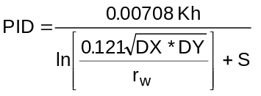

where, K = layer absolute permeability, md
h = layer thickness, feet
DX = x-direction grid block dimension, feet
DY = y-direction grid block dimension, feet
r_{w} = wellbore radius, feet
s = layer skin factor

Further discussion of the layer flow index (PID) and its relation to field-measured productivity index is included in Chapter 6 of Volume I.

PWF = Layer flowing bottomhole pressure (FBHP), psia. This value is used only if KIP is negative for this well. If rates are specified for this well (KIP = +1, +2, or +3), set PWF = 0.

NOTE: Formation damage or stimulation at any point in time can be handled on a layer-by-layer basis by changing the layer PI.

Very Important! Once a well has been completed in a certain layer, that layer must continue to be specified on all succeeding well information cards, even if the layer or well is shut in! To shut in a layer, set that layer PID = 0. To shut in a well, set all of its layer PID's to zero.
Chapter 4.
PROGRAM OUTPUT EVALUATION

This chapter provides a brief description of the BOAST program output. An example program output is included in the Appendix for your reference. (This is the output to the two-dimensional areal example run discussed in Chapter 5.)

Initialization Data

BOAST always outputs the following initialization data:

1. Grid block sizes;
2. Node midpoint elevations;
3. Porosity distribution;
4. Permeability distribution;
5. Relative permeability and capillary pressure table;
6. PVT table;
7. Slopes calculated from PVT data (including units conversion for internal program use);
8. Time step control data;
9. Initial fluid volumes-in-place;
10. Initial pressure and saturation arrays; and
11. Initial well information.

Other output can be obtained at the user's command. For example, whenever a modification option is activated, the user may print out the altered array. It is worthwhile to do this as a check on the input modifications.

Recurrent Data

Information obtained during the course of the computer run is output, at the user's discretion, in essentially three formats:

1. Well report;
2. Summary report; and
3. Pressure and saturation distribution arrays.

Well Report:

Rates and cumulative production/injection data for each layer of each well are summarized in the well report at user-specified times. Field totals are also included. Units of GOR and WOR are SCF/STB and STB/STB, respectively.

Summary Report:

The Summary Report is the single most useful report of the three output reports. It contains a concise summary of total field production and injection, time step and material balance information, and a determination of where maximum pressure and saturation changes are occurring in the reservoir model. This information is usually sufficient for monitoring the model performance when more detailed output is not needed.

Material balance estimates and their meaning are discussed in Volume I. As a general rule, maximum saturation changes should be under 10 percent. If a maximum saturation change exceeds 10 percent but does not persist for many additional time steps, it indicates the program encountered a temporary instability but recovered. On the other hand, changes consistently above 10 percent indicate problems are present. In either case, it is wise to decrease the time step size, at least during the period of excessive saturation changes, to determine if the computed results are significantly affected.

Unlike the Well Report, the WOR and GOR output in the Summary Report are ratios of total producing fluid rates. Consequently, these ratios are comparable to observed field-wide ratios.

Distribution Arrays:

The user may output the pressure, saturation, and bubble point pressure arrays whenever desired. It is usually unnecessary to print out all five arrays. The user is advised to be judicious in specifying output. This can avoid the printing of unnecessarily thick outputs. Normally, the bubble point pressure array need not ever be printed out. This array provides mainly diagnostic type information.

Chapter 5.
EXAMPLE INPUT DATA FILES AND PROGRAM VALIDATION

This chapter provides five example problems which have been solved using the BOAST simulator. These examples cover a range of different model grid configurations and reservoir conditions:

1. One-dimensional, linear model grid showing Buckley-Leverett waterflood displacement.

2. Two-dimensional, areal model grid showing primary depletion of an undersaturated reservoir.

3. Two-dimensional, X-Z cross-sectional model grid showing waterflooding of a layered system with multi-zone completions.

4. Three-dimensional model grid of a heterogeneous 40-acre, five-spot pattern area showing primary depletion by fluid expansion and solution gas drive followed by drilling of additional wells and waterflooding the partially depleted reservoir.

5. Comparative solution example problem: three-dimensional model grid with high-pressure gas injection into an initially undersaturated oil reservoir showing oil production by depletion and gas displacement.

In most of these examples, the BOAST solution is compared with either an analytical solution (in the case of the Buckley-Leverett problem) or with the solution of one or more commercially available black oil simulators on the same problem.

One important point to note is that in complex, heterogeneous problems, such as examples 4 and 5, there are significant differences in the results obtained with different commercially available simulators. This is especially noticeable when specific results, such as oil rate or GOR at a given point in time, are compared. However, the general behavior of reservoir performance predictions is similar for all of the simulators. This should reinforce the point that reservoir simulators do not provide the answer in terms of exact oil rates, recovery, breakthrough times, etc. Reservoir simulators are tools which, when supplied with sufficient valid reservoir description data, can provide a reasonable forecast of the general performance to be expected from a reservoir under user-specified operating conditions and constraints. Results from a reservoir simulation study must be viewed as an approximation to the expected performance and not as an exact performance prediction.

Program Validation

While BOAST has been tested and compared with analytical solutions and results of other commercially available black oil simulators on a variety of problems, the program has not been exhaustively tested in all of its options and features against every possible combination of factors and conditions. Completely comprehensive validation is not practical due to the complexity of the simulator and the great time and cost involved. This is the usual case with most simulators, including commercially marketed simulators. Consequently, we strongly recommend that results from any simulation be viewed critically and checked for “reasonableness" before the results are accepted.

Example 1: One-Dimensional Linear Model Showing Buckley-Leverett Calculation

There are very few analytical solutions available which can be used to check black oil simulators. One such solution is the Buckley-Leverett line-drive waterflood calculation. This calculation provides a test of the saturation calculations performed by BOAST.

Data for the Buckley-Leverett example are presented as BOAST input data on a standard FORTRAN coding form in Table 5.1. A one-dimensional linear grid is constructed as a model of a homogeneous, level (zero-dip angle) reservoir. Special attention should be directed toward the format structure of the relative permeability and fluid PVT data tables. These tables illustrate the flexibility of the F10.0 format. Similar flexibility in locating the decimal point also applies to the F8.0 format. The integer format I5, however, must be right justified as shown.

Oil production under a rate constraint of 600 STB (βo = 1.50) per day from one end grid block is balanced by water injection under rate constraint of 900 STB (β_{o} = 1.00) per day into the opposite end grid block. Porosity modifications in the end grid blocks have been made to account for the block-centered formulation of the finite difference equations. Frontal advance results from the BOAST calculation are plotted against the analytical solution in Figure 5.1.

Table 5.1. Input Data for Example 1




  

  




   




   





     
   
   

   
  😐 😐 😐  
   
   
   
   
   
   
   
   
   
   
   
     
    
   
   
   
   
   
   
   
   
   
   
   
   
   
   
   
   
   
   
   
  
  

 
   
  
😐 😐 😐 😐 
    
       
       
   ☹ ☹  
      



        
  


         
 
☺         
 
        
  
        
  
        
  
        
  
        
  
        
  
        
  
        
  
        
  
        
  
FIGURE 5.1
BOAST Simulation of a Linear Buckley-Leverett Waterflood Displacement

Water Saturation

Injector Producer
1.0

0.8 X
X X X X X X X X X
O O O O X X X
360 Days
0.6 O X
O 120 Days X

0.4 O X

O X
0.2 O O O O X X O X O X

0 1.0

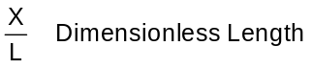

O
BOAST
Analytical Solution
X

Numerical Dispersion:

Figure 5.1 shows good agreement except at the piston-like displacement front. The water saturations calculated by the simulator are smeared, or dispersed, relative to the Buckley-Leverett front. This dispersing of the saturation front is a phenomenon inherent in all finite difference simulators and is known as numerical dispersion. Numerical dispersion is discussed in detail in Appendix A of Volume I of the BOAST documentation.

An estimate of the value of numerical dispersion of the BOAST formulation present in the Buckley-Leverett example is given by

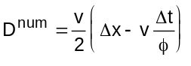 5.1

where, v = frontal advance rate (feet per day),
Δx = grid block size in the direction of frontal advance (feet),
Δt = time step size (day),
φ = porosity (fraction),
and D^{num} = numerical dispersion (feet² per day).
For our example, v ≈ 1.5 feet per day, φ = 0.25, Δx = 20 feet, and Δt = 3 days which gives the value of D^{num} to be about 1.5² feet per day. Although small, this value of D^{num} results in a noticeable smearing of the saturation front shown in Figure 5.1. More grid blocks could be used to further reduce the smearing if the time step size is adjusted such that

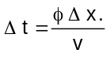 5.2

Equation (5.2) is a good expression for estimating an optimum time step size. The maximum time step size is determined by saturation and pressure change requirements in addition to Equation (5.2).

Before proceeding to higher dimensional examples, an important point should be noted. There is a widespread misconception in the industry that numerical dispersion can always be reduced by decreasing time step size. This is true only for simulators employing implicit saturation formulations. We see from Equation (5.1) that a decrease in time step size in an IMPES simulator like BOAST increases numerical dispersion. This should be borne in mind when attempting to sharpen IMPES simulator calculated saturation fronts.

Example 2: Two-Dimensional Areal Model Showing Primary Depletion of an Undersaturated Reservoir

This example shows a single well producing from the center of a two-dimensional areal reservoir model grid. The reservoir has areally varying porosity and is initially 1,400 psi undersaturated. The well is rate constrained to a 300 BOPD allowable with production coming from fluid expansion drive.

The input data file for this example is shown in Table 5.2. The results from this example illustrate primarily the simulator pressure solution, as saturations do not change for the undersaturated reservoir. The BOAST pressure solution is presented in Figure 5.2 along with the solutions to this same problem run on two commercially available black oil simulators.

The complete BOAST output for this run through the first time step is presented in the Appendix.

TABLE 5.2 - Input Data for Example 2

BOAST VALIDATION RUN - PRESSURE COMPARISON EXAMPLE

9 9 1
GRID BLOCK LENGTHS
0 0 -1
160. 160. 160. 160. 80. 160. 160. 160 160
160. 160. 160. 160. 80. 160. 160. 160 160
30.
GRID BLOCK LENGTH MODIFICATIONS
0 0 0 0
DEPTH TO TOP OF SAND
0
8345.
POROSITY AND PERMEABILITY DISTRIBUTIONS
+1 -1 -1 -1
0.28 | 0.28 | 0.28 | 0.28 | 0.28 | 0.28 | 0.28 | 0.28 | 0.28
0.28 | 0.28 | 0.28 | 0.28 | 0.28 | 0.28 | 0.28 | 0.28 | 0.28
0.28 | 0.28 | 0.28 | 0.28 | 0.28 | 0.28 | 0.28 | 0.28 | 0.28
0.28 | 0.28 | 0.28 | 0.28 | 0.28 | 0.28 | 0.28 | 0.28 | 0.28
0.28 | 0.28 | 0.28 | 0.28 | 0.28 | 0.28 | 0.28 | 0.28 | 0.28
0.30 | 0.30 | 0.30 | 0.30 | 0.30 | 0.30 | 0.30 | 0.30 | 0.30
0.30 | 0.30 | 0.30 | 0.30 | 0.30 | 0.30 | 0.30 | 0.30 | 0.30
0.30 | 0.30 | 0.30 | 0.30 | 0.30 | 0.30 | 0.30 | 0.30 | 0.30
0.30 | 0.30 | 0.30 | 0.30 | 0.30 | 0.30 | 0.30 | 0.30 | 0.30
100.
100.
100.
POROSITY AND PERMEABILITY MODIFICATION CARDS
0 0 0 0 0
0 0 0 0
TRANSMISSIBILITY MODIFICATIONS
0 0 0 0
SAT | KRO | KRW | KRG | PCOW | PCGO
-0.10 | 0.00 | 0.00 | 0.00
0.02 | 0.00 | 0.00 | 0.00
0.12 | 0.00 | 0.00 | 0.02
0.20 | 0.00 | 0.02 | 0.06
0.30 | 0.00 | 0.04 | 0.20
0.40 | 0.03 | 0.07 | 0.46
0.50 | 0.09 | 0.12 | 0.70
0.60 | 0.17 | 0.18 | 0.87
0.70 | 0.30 | 0.27 | 0.91
0.80 | 0.50 | 0.51 | 0.94
0.88 | 0.75 | 0.71 | 0.97
1.00 | 1.00 | 1.00 | 1.00
1.10 | 1.00 | 1.00 | 1.00

PBO | VSLOPE | BSLOPE | RSLOPE | PMAX
4014.7 | .000046 | -.0000232 | 0.0 | 9014.7
P | MUO | BO | RSO
14.7 | 1.0400 | 1.0620 | 1.0
264.7 | 0.9750 | 1.1500 | 90.5
514.7 | 0.9100 | 1.2070 | 180.0
1014.7 | 0.8300 | 1.2950 | 371.0
2014.7 | 0.6950 | 1.4350 | 636.0
2514.7 | 0.6410 | 1.5000 | 775.0
3014.7 | 0.5910 | 1.5650 | 930.0
4014.7 | 0.5100 | 1.6950 | 1270.0
5014.7 | 0.4490 | 1.8270 | 1618.0
9014.7 | 0.2030 | 2.3570 | 2984.0
P | MUW | BW | RSW
14.7 | 0.5000 | 1.0190 | 0.0
1014.7 | 0.5010 | 1.0160 | 0.0
2014.7 | 0.5020 | 1.0130 | 0.0
4014.7 | 0.5050 | 1.0070 | 0.0
6014.7 | 0.5100 | 1.0010 | 0.0
9014.7 | 0.5200 | 0.9920 | 0.0
P | MUG | BG | CR
14.7 | 0.008000 | 0.935800 | 0.000003
264.7 | 0.009600 | 0.067902 | 0.000003
514.7 | 0.011200 | 0.035228 | 0.000003
1014.7 | 0.014000 | 0.017951 | 0.000003
2014.7 | 0.018900 | 0.009063 | 0.000003
2514.7 | 0.020800 | 0.007266 | 0.000003
3014.7 | 0.022800 | 0.006061 | 0.000003
4014.7 | 0.026800 | 0.04554 | 0.000003
5014.7 | 0.030900 | 0.003611 | 0.000003
9014.7 | 0.047000 | 0.002167 | 0.000003
RHOSCO | RHOSCW | RHOSCG
46.244 | 62.238 | 0.0647
EQUILIBRIUM PRESSURE INITIALIZATION / CONSTANT SATURATION INITIALIZATION
0 0
5400.0 0.0 8425.0 8300.0
0.88 0.12 0.00
KSN1 KTR KSM1 KCO1 KCOF
0 0 0 0 0
NMAX FACT1 FACT2 TMAX WORMAX GORMAX PAMIN PAMAX
2000 1.25 0.50 1460.0 20.0 500000.0 150.0 20000.0
KSOL MITR OMEGA TOL TOL1 DPMAX DPMAX
3 250 1.70 0.100 0.000 0.05 100.0
RECURRENT DATA
1 | 1 | 1 | 1 | 1 | 1 | 1 | 1 | 1
 | 1.0 |  | 1.0 |  | 1.0
WELL P-1 PRODUCING AT 300 BOPD
1
P-1 | 5 | 5 | 1 | 1 | 1 | 300.0 | 0.0 | 0.0 | 0.0
 | 0.30 |  | 0.0
0 | 8 | 0 | 0 | 0 | 0 | 0 | 0 | 0
 | 1.0 |  | 1.0 |  | 1.0
0 | 1 | 1 | 1 | 1 | 1 | 0 | 1 | 1
 | 1.0 |  | 1.0 |  | 1.0
0 | 9 | 0 | 0 | 0 | 0 | 0 | 0 | 0
 | 1.0 |  | 1.0 |  | 1.0
0 | 1 | 1 | 1 | 1 | 1 | 0 | 1 | 1
 | 1.0 |  | 1.0 |  | 1.0
0 | 9 | 0 | 0 | 0 | 0 | 0 | 0 | 0
 | 1.0 |  | 1.0 |  | 1.0
0 | 1 | 1 | 1 | 1 | 1 | 0 | 1 | 1
 | 1.0 |  | 1.0 |  | 1.0
0 | 9 | 0 | 0 | 0 | 0 | 0 | 0 | 0
 | 1.0 |  | 1.0 |  | 1.0
0 | 1 | 1 | 1 | 1 | 1 | 0 | 1 | 1
 | 1.0 |  | 1.0 |  | 1.0
0 | 9 | 0 | 0 | 0 | 0 | 0 | 0 | 0
 | 1.0 |  | 1.0 |  | 1.0
0 | 1 | 1 | 1 | 1 | 1 | 0 | 1 | 1
 | 1.0 |  | 1.0 |  | 1.0
0 | 9 | 0 | 0 | 0 | 0 | 0 | 0 | 0
 | 1.0 |  | 1.0 |  | 1.0
0 | 1 | 1 | 1 | 1 | 1 | 0 | 1 | 1
 | 1.0 |  | 1.0 |  | 1.0
0 | 9 | 0 | 0 | 0 | 0 | 0 | 0 | 0
 | 1.0 |  | 1.0 |  | 1.0
0 | 1 | 1 | 1 | 1 | 1 | 0 | 1 | 1
 | 1.0 |  | 1.0 |  | 1.0
0 | 9 | 0 | 0 | 0 | 0 | 0 | 0 | 0
 | 1.0 |  | 1.0 |  | 1.0
0 | 1 | 1 | 1 | 1 | 1 | 0 | 1 | 1
 | 1.0 |  | 1.0 |  | 1.0
0 | 9 | 0 | 0 | 0 | 0 | 0 | 0 | 0
 | 1.0 |  | 1.0 |  | 1.0
0 | 1 | 1 | 1 | 1 | 1 | 0 | 1 | 1
 | 1.0 |  | 1.0 |  | 1.0

FIGURE 5.2
Comparison of BOAST Pressure Solution
with commercial black oil simulators on Example Problem 2.

Pressure in Producing Well Block (psia
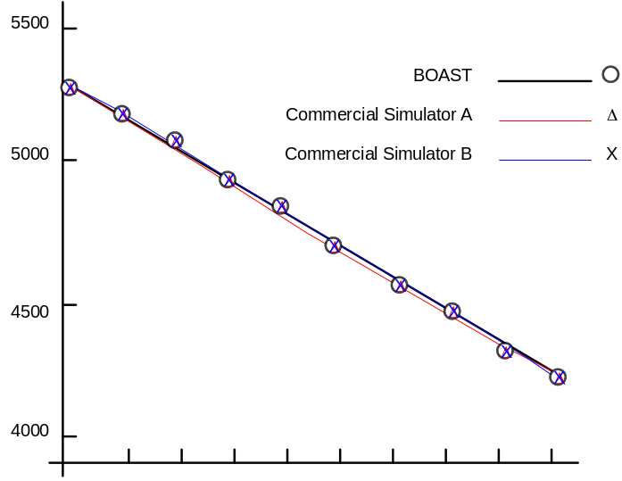
0
0 10 20 30 40 50 60 70 80 90
Time in Days

Example 3 Cross-Section Model Showing Line-Drive Waterflooding of an Undersaturated Reservoir

The input data file for an x-z cross-section example is presented in Table 5.3. A linear grid with NX = 20, NY = 1, and NZ = 5 has been constructed. Each end grid block contains a well. Porosity is halved in the end grid blocks to account for the block-centered finite difference formulation. A vertical to horizontal permeability ratio of 0.1 is used.

Production is from a well completed in layers 2, 3, and 5. Notice that the value of NLAYER in the well information cards must include layer 4, but the well flow index for layer 4 is set to zero. This effectively shuts in layer 4. A rate specified water injection well is completed in layers 4 and 5 at the end opposite to the production well location.

Performance of the production well is plotted in Figure 5.3. An essentially constant oil production rate is maintained in the pressure constrained production well until water breakthrough. Breakthrough occurs first in the lowermost layer 5, followed by layer 3 and then the uppermost layer 2 as expected. Oil production falls off rapidly as shown in Figure 5.3. The simulation terminates when the specified limiting water/oil ratio of WORMAX = 20 is reached at around 275 days.

TABLE 5.3 - Input data for Example 3

LINE DRIVE WATERFLOOD: CROSS-SECTION RUN.

20 1 5
GRID BLOCK LENGTHS
-1 -1 -1
20.0
500.0
10.
GRID BLOCK LENGTH MODIFICATIONS
0 0 0 0
CAPROCK BASE DEPTHS
0
8325.
POROSITY AND PERMEABILITY’
-1 -1 -1 -1
0.250
200.
200.
20.
POROSITY AND PERMEABILITY MODIFICATION CARDS
10 0 0 0 1
1 1 1 0.125
1 1 2 0.125
1 1 3 0.125
1 1 4 0.125
1 1 5 0.125
20 1 1 0.125
20 1 2 0.125
20 1 3 0.125
20 1 4 0.125
20 1 5 0.125
TRANSMISSIBILITY MODIFICATIONS
0 0 0 00
SAT KRO KRW KRG PCGO PCOW
-.10 0.0 0.0 0.0
0.02 0.0 0.0 0.0
0.10 0.0 0.0 0.025
0.20 .00147 .0000 .075
0.30 .00228 .0122 0.190
0.40 0.0370 .0244 0.410
0.50 0.0571 .0336 0.72
0.60 0.134 .0672 0.87
0.70 0.207 .1344 0.94
0.80 0.604 .2688 0.9666667
0.90 1.000 .4704 0.9933333
1.1 1.0 .5000 1.0
PBO VSLOPE BSLOPE RSLOPE PMAX
4014.7 .000046 -.0000232 0.0 9014.7
P MUO BO RSO
14.7 1.0400 1.0620 1.0
1014.7 0.8300 1.2950 371.0
2014.7 0.6950 1.4350 636.0
3014.7 0.5940 1.5650 930.0
4014.7 0.5100 1.6950 1270.0
5014.7 0.4490 1.8270 1618.0
9014.7 0.2030 2.3570 2984.0
P MUW BW RSW
14.7 0.5000 1.0190 0.0
1014.7 0.5010 1.0160 0.0
2014.7 0.5020 1.0130 0.0
4014.7 0.5050 1.0070 0.0
6014.7 0.5100 1.0010 0.0
9014.7 0.5200 0.9920 0.0
P MUG BG CR
14.7 0.008000 0.935800 0.000003
264.7 0.009600 0.067902 0.000003
514.7 0.011200 0.35228 0.000003
1014.7 0.014000 0.017951 0.000003
2014.7 0.018900 0.009063 0.000003
2514.7 0.020800 0.007266 0.000003
3014.7 0.022800 0.006064 0.000003
4014.7 0.026800 0.004554 0.000003
5014.7 0.30900 0.003644 0.000003
9014.7 0.047000 0.002167 0.000003
RHOSCO RHOSCW RHOSCG
46.244 62.238 0.0647
EQUILIBRIUM PRESSURE INITIALIZATION / CONSTANT SATURATIONS
0 0
5015.0 0.0 8425.0 8300.0
] 0.80 0.20 0.0
KSN1 KSM1 KCO1 KTR KCOF
0 0 0 0 0
NMAX FACT1 FACT2 TMAX WORMAX GORMAX PAMIN PAMAX
500 1.20 0.50 365.0 20.0 500000.0 150.0 10000.0
KSOL MITR OMEGA TOL TOL1 DSMAX DPMAX
3 100 1.70 0.100 0.0000 0.05 100.0
RECURRENT DATA
1 1 1 1 1 1 1 0 0
1.0 0.1 10.0
RATES
2
PROD 20 1 02 4 -1 600.00 0.0 0.0 0.0
0.50 4015.0
0.75 4015.0
0.00 4015.0
0.25 4015.0
INJ1 1 1 4 2 +2 0.0 -900.0 0.0 0.0
0.25 5015.0
0.50 5015.0
0 8 0 0 0 0 0 0 0
1.0 0.1 10.0
0 1 1 1 1 1 1 0 0
1.0 0.1 10.0
0 9 0 0 0 0 0 0 0
2.0 0.1 10.0
0 1 1 1 1 1 1 0 0
2.0 0.1 10.0
0 9 0 0 0 0 0 0 0
6.0 0.1 30.0
0 1 1 1 1 1 1 0 0
6.0 0.1 30.0
0 14 1 1 1 1 1 0 0
6.0 0.1 30.0
0 1 1 1 1 1 1 0 0
6.0 0.1 30.0
0 4 1 1 1 1 1 0 0
6.0 0.1 30.0
0 1 1 1 1 1 1 0 0
6.0 0.1 30.0
0 4 1 1 1 1 1 0 0
6.0 0.1 30.0
0 1 1 1 1 1 1 0 0
6.0 0.1 30.0
0 4 1 1 1 1 1 0 0
6.0 0.1 30.0
0 1 1 1 1 1 1 0 0
6.0 0.1 30.0
0 4 1 1 1 1 1 0 0
6.0 0.1 30.0
0 1 1 1 1 1 1 0 0
6.0 0.1 30.0
0 4 1 1 1 1 1 0 0
6.0 0.1 30.0
0 1 1 1 1 1 1 0 0
6.0 0.1 30.0
0 4 1 1 1 1 1 0 0
6.0 0.1 30.0
0 1 1 1 1 1 1 0 0
6.0 0.1 30.0
0 4 1 1 1 1 1 0 0
6.0 0.1 30.0
0 1 1 1 1 1 1 0 0
6.0 0.1 30.0
0 4 1 1 1 1 1 0 0
6.0 0.1 30.0
0 1 1 1 1 1 1 0 0
6.0 0.1 30.0

FIGURE 5.3
Production Performance for Example 3

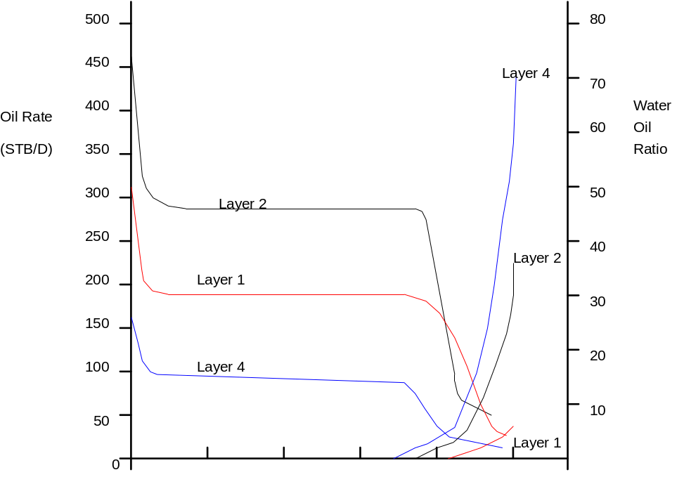
0 50 100 150 200 250
Cumulative Water Injection (MSTB)

Example 4: Three-Dimensional, 40-Acre, Five-Spot Waterflood

This example illustrates the data input and results for a fairly comprehensive waterflooding problem. The reservoir consists of two communicating zones with different reservoir properties. Porosity varies within each zone from north to south.

Initial production is by fluid expansion drive from an undersaturated reservoir followed by solution gas drive. After the reservoir has been partially depleted, four water injection wells are drilled to form a 40-acre, five-spot pattern and the field is then waterflooded.

The central producing well is operated under a specified oil production rate constraint to match the historical rate decline. The producing well is operated under a flowing bottomhole pressure constraint during the waterflood prediction. The input data file for the BOAST simulation of this problem is shown in Table 5.4.

This same problem was run on two commercially available black oil simulators for comparison with the BOAST runs. The oil production, water production, gas production, and production well block pressure performance of all three simulators is presented in Figures 5.4 through 5.7.

All three simulations show the same general trend of reservoir performance. However, it is important to note that at any particular point in the simulation, some significant differences in specific parameters such as oil production rate or gas production rate occur between all simulations. In most cases, the differences between BOAST and the closest commercial simulator are less than the differences between the two commercial simulators.

This illustrates the point that on more complex problems -- problems including the effects of reservoir heterogeneities, possible three-phase relative permeability effects, fluid repressurization effects, etc. -- there are no analytically "correct" solutions. Different simulators use different algorithms, fluid properties packages, and so forth to simulate the response of the reservoir system. Therefore, exact numerical predictions cannot be expected. However, all of the simulators should be expected to, and in fact do, give the same general performance trends and estimates. They all provide a reasonable basis on which to make an engineering decision concerning waterflooding in this field.

TABLE 5.4 - Input data for Example 4

BOAST VALIDATION RUN - WATERFLOOD EXAMPLE
9 9 2
GRID BLOCK LENGTHS
0 0 0
160. 160. 160 160. 80. 160. 160 160. 160.
160. 160. 160. 160. 80. 160. 160. 160. 160.
20. 30.
GRID BLOCK LENGTH MODIFICATIONS
0 0 0 0
DEPTH TO TOP OF UPPER SAND ZONE
0
8325.
POROSITY AND PERMEABILITY DISTRIBUTIONS
+1 0 0 -1
0.12 0.12 0.12 0.12 0.12 0.12 0.12 0.12 0.12
0.12 0.12 0.12 0.12 0.12 0.12 0.12 0.12 0.12
0.12 0.12 0.12 0.12 0.12 0.12 0.12 0.12 0.12
0.12 0.12 0.12 0.12 0.12 0.12 0.12 0.12 0.12
0.12 0.12 0.12 0.12 0.12 0.12 0.12 0.12 0.12
0.14 0.14 0.14 0.14 0.14 0.14 0.14 0.14 0.14
0.14 0.14 0.14 0.14 0.14 0.14 0.14 0.14 0.14
0.14 0.14 0.14 0.14 0.14 0.14 0.14 0.14 0.14
0.14 0.14 0.14 0.14 0.14 0.14 0.14 0.14 0.14
0.28 0.28 0.28 0.28 0.28 0.28 0.28 0.28 0.28
0.28 0.28 0.28 0.28 0.28 0.28 0.28 0.28 0.28
0.28 0.28 0.28 0.28 0.28 0.28 0.28 0.28 0.28
0.28 0.28 0.28 0.28 0.28 0.28 0.28 0.28 0.28
0.28 0.28 0.28 0.28 0.28 0.28 0.28 0.28 0.28
0.30 0.30 0.30 0.30 0.30 0.30 0.30 0.30 0.30
0.30 0.30 0.30 0.30 0.30 0.30 0.30 0.30 0.30
0.30 0.30 0.30 0.30 0.30 0.30 0.30 0.30 0.30
0.30 0.30 0.30 0.30 0.30 0.30 0.30 0.30 0.30
20. 100.
20. 100.
5.
POROSITY AND PERMEABILITY MODIFICATION CARDS
0 0 0 0 0
TRANSMISSIBILITY MODIFICATIONS
0 0 0 0
SAT KRO KRW KRO PCOW PCGO
-0.10 0.00 0.00 0.00
0.02 0.00 0.00 0.00
0.12 0.00 0.00 0.02
0.20 0.00 0.02 0.06
0.30 0.00 0.04 0.20
0.40 0.03 0.07 0.46
0.50 0.09 0.12 0.70
0.60 0.17 0.18 0.87
0.70 0.30 0.27 0.91
0.80 0.50 0.51 0.94
0.88 0.75 0.71 0.97
1.00 1.00 1.00 1.00
1.10 1.00 1.00 1.00
PBO VSLOPE BSLOPE RSLOPE PMAX
4014.7 .000046 -.0000232 0.0 9014.7 0
P MUO BO RSO
14.7 1.0400 1.0620 1.0
264.7 0.975O 1.1500 90.5
514.7 0.9100 1.2070 180.0
1014.7 0.8300 1.2950 371.0
2014.7 0.6950 1.4350 636.0
2514.7 0.6410 1.5000 775.0
3014.7 0.5940 1.5650 930.0
4014.7 0.5100 1.6950 1270.0
5014.7 0.4490 1.8270 1618.0
9014.7 0.2030 2.3570 2984.0
P MUW BW RSW
14.7 0.5000 1.0190 0.0
1014.7 0.5010 1.0160 0.0
2014.7 0.5020 1.0130 0.0
4014.7 0.5050 1.0070 0.0
6014.7 0.5100 1.0010 0.0
9011.7 0.5200 0.9920 0.0
P MUG BG CR
14.7 0.008000 0.935800 0.000003
264.7 0.009600 0.067902 0.000003
514.7 0.011200 0.035228 0.000003
1014.7 0.014000 0.017951 0.000003
2014.7 0.018900 0.009063 0.000003
2514.7 0.020800 0.007266 0.000003
3014.7 0.022800 0.006064 0.000003
4014.7 0.026800 0.006554 0.000003
5014.7 0.030900 0.003664 0.000003
9014.7 0.047000 0.002167 0.000003
RHOSCO RHOSCW RHOSCG
46.244 62.238 0.0647
EQUILIBRIUM PRESSURE INITIALIZATION / CONSTANT SATURATION INITIALIZATION
0 0
4400.0 0.0 8425.0 8300.0
0.88 0.12 0.00
KSN1 KTR KSM1 KCO1 KCOF
0 0 0 0 0
NMAX FACT1 FACT2 TMAX WORMAX GORMAX PAMIN PAMAX
2000 1.25 0.50 1460.0 20.0 500000.0 150.0 20000.0
KSOL MITR OMEGA TOL. TOL1 DSMAX DPMAX
2 250 1.70 0.100 0.0000 0.05 100.0
RECURRENT DATA
1 1 1 1 1 1 1 1 1
1.0 1.0 1.0
WELL P-1 (COMPLETED IN BOTH UPPER (AND LOWER ZONES) @ 850 BOPD
1
P-1 5 5 1 2 1 850.0 0.0 0.0 0.0
0.04 0.0
0.30 0.0
0 8 0 0 0 0 0 0 0
1.0 0.1 30.0
0 1 1 1 1 1 0 1 1
1.0 0.1 30.0
0 79 0 0 0 0 0 0 0
1.0 0.1 3.60
0 1 1 1 1 1 0 1 1
1.0 0.1 30.0
1 1 1 1 1 1 0 1 1
1.0 1.0 30.0
WELL P-1 RATE CHANGED TO 600 BOPD
1
P-1 5 5 1 2 1 600.0 0.0 0.0 0.0
0.04 0.0
0.30 0.0
0 89 0 0 0 0 0 0 0
1.0 0.1 30.0
0 1 1 1 1 1 0 1 0
1.0 0.1 30.0
1 1 1 1 1 1 0 1 0
1.0 1.0 30.0
WELL P-1 RATE CHANGED TO 160 BOPD
1
P-1 5 5 1 2 1 460.0 0.0 0.0 0.0
0.04 0.0
0.30 0.0
0 89 0 0 0 0 0 0 0
1.0 0.1 30.0
0 1 1 1 1 1 0 1 0
1.0 0.1 30.0
1 1 1 1 1 1 0 1 0
1.0 1.0 30.0
WELL- P-1 RATE CHANGED TO 380 BOPD
1
P-1 5 5 1 2 1 380.0 0.0 0.0 0.0
0.04 0.0
0.30 0.0
0 91 0 0 0 0 0 0 0
1.0 0.1 30.0
0 1 1 1 1 1 0 1 0
1.0 0.1 30.0
1 1 1 1 1 1 0 1 0
1.0 1.0 30.0
PUT WELL P-1 ON FBHP CONTROL & BEGIN WATER INJECTION IN I-1 THRU I-4
5
P-1 5 5 1 2 -1 0.0 0.0 0.0 0.0
0.04 500.0
0.30 500.0
I-1 1 1 2 1 2 0.0 -500.0 0.0 0.0
0.50 0.0
I-2 1 9 2 1 2 0.0 -500.0 0.0 0.0
0.50 0.0
I-3 9 1 2 1 2 0.0 -500.0 0.0 0.0
0.50 0.0
I-4 9 9 2 1 2 0.0 -500.0 0.0 0.0
0.50 0.0
0 89 0 0 0 0 0 0 0
1.0 0.1 30.0
0 1 1 1 1 1 1 1 0
1.0 0.1 30.0
0 91 0 0 0 0 0 0 0
1.0 0.1 30.0
0 1 1 1 1 1 1 1 0
1.0 0.1 30.0
0 90 0 0 0 0 0 0 0
1.0 0.1 30.0
0 1 1 1 1 1 1 0
1.0 0.1 30.0
0 90 0 0 0 0 0 0 0
1.0 0.1 30.0
0 1 1 1 1 1 1 1 0
1.0 0.1 30.0
0 90 0 0 0 0 0 0 0
1.0 0.1 30.0
0 1 1 1 1 1 1 1 0
1.0 001 30.0
0 91 0 0 0 0 0 0 0
1.0 0.1 30.0
0 1 1 1 1 1 1 1 0
1.0 0.1 30.0
0 90 0 0 0 0 0 0 0
1.0 0.1 30.0
0 1 1 1 1 1 1 1 0
1.0 0.1 30.0
0 90 0 0 0 0 0 0 0
1.0 0.1 30.0
0 1 1 1 1 1 1 1 0
1.0 0.1 30.0
0 90 0 0 0 0 0 0 0
1.0 0.1 30.0
0 1 1 1 1 1 1 1 0
1.0 0.1 30.0
0 91 0 0 0 0 0 0 0
1.0 0.1 30.0
0 1 1 1 1 1 1 1 0
1.0 0.1 30.0
0 90 0 0 0 0 0 0 0
1.0 0.1 30.0
0 1 1 1 1 1 1 1 0
1.0 0.1 30.0
0 90 0 0 0 0 0 0 0
1.0 0.1 30.0
0 1 1 1 1 1 1 1 0
1.0 0.1 30.0
0 90 0 0 0 0 0 0 0
1.0 0.1 30.0
0 1. 1 1 1 1 1 1 0
1.0 0.1 30.0
0 91 0 0 0 0 0 0 0
1.0 0.1 30.0
0 1 1 1 1 1 1 1 0
1.0 0.1 30.0
0 90 0 0 0 0 0 0 0
1.0 0.1 30.0
0 1 1 1 1 1 1 1 0
1.0 0.1 30.0
0 90 0 0 0 0 0 0 0
1.0 0.1 30.0
0 1 1 1 1 1 1 1 0
1.10 0.1 30.0

FIGURE 5.4 -- Oil Production vs. Time for Example 4

Oil Rate (STB/D)
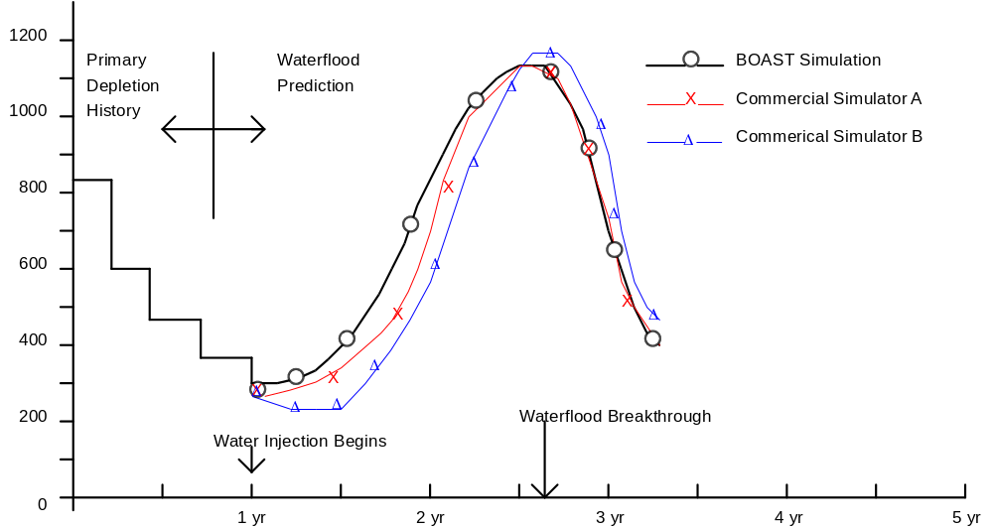
Time (Years)

FIGURE 5.5 -- Water Production vs. Time for Example 4

Water rate (STB/D)
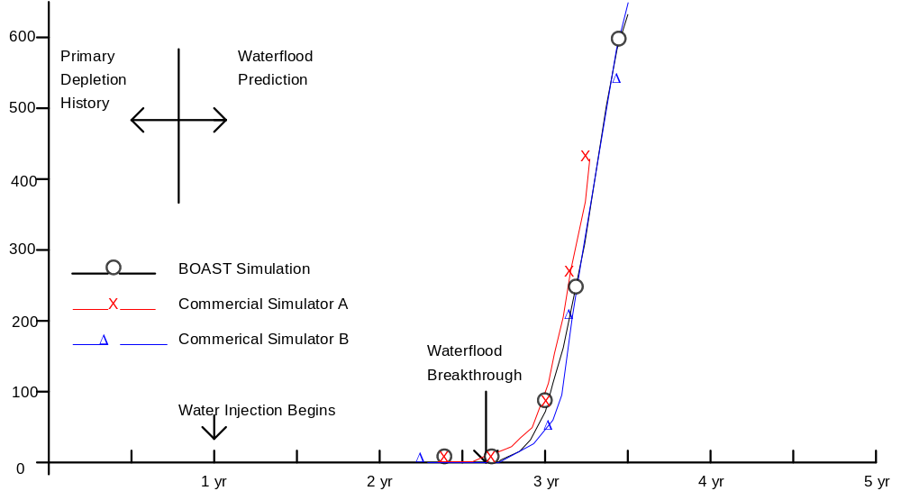
Time (Years)
FIGURE 5.6 -- Gas Production vs. Time for Example 4

Gas Rate (MCF/D)
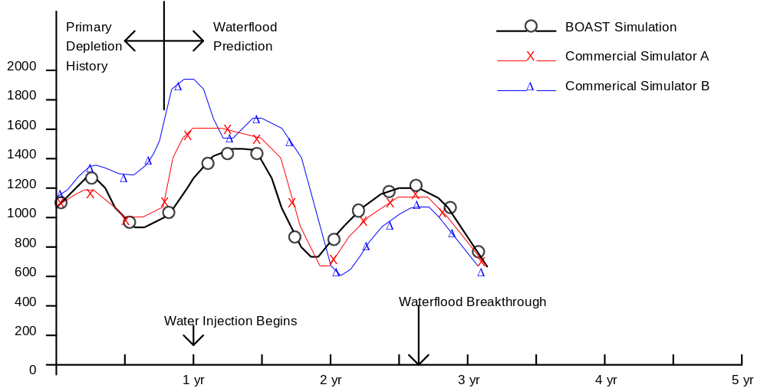Time (Years)

FIGURE 5.7 -- Production Well Block Pressure vs. Time for Example 4

Pressure (psia)
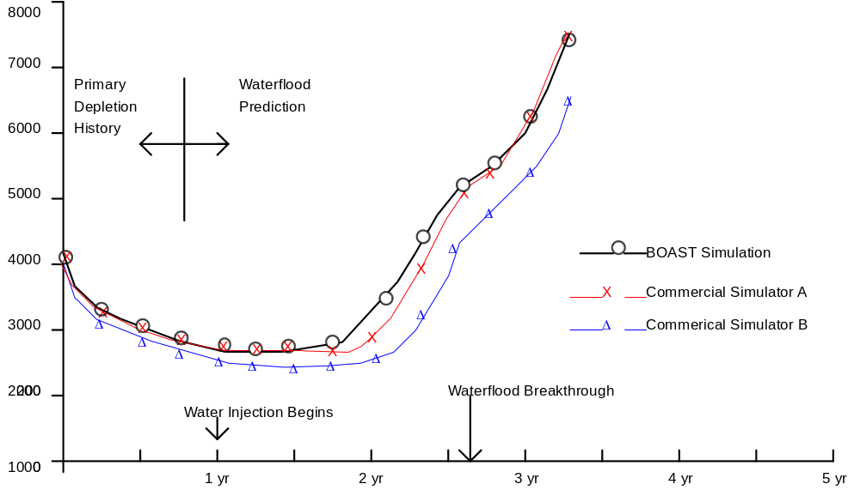
Time (Years)
Example 5: Comparative Solution Problem

As a part of the testing and validation of the BOAST black oil simulator, the program was run against the three-dimensional black oil reservoir simulation comparative solution problem published by Odeh* .

The problem involved simultaneous gas injection into and oil production from an initially undersaturated black oil reservoir. A three-layer model grid was specified with gas injection into the upper layer in one corner and oil production from the lower layer in the opposite corner. The model grid configuration and problem specifications are reproduced from the Odeh article in Figure 5.8 and Table 5.5. The problem actually solved was that of Case 2 in the JPT article in which saturation pressures were allowed to vary with gas saturation.

Seven companies -- four major oil companies and three consulting companies -- solved the same problem using their in-house or commercially marketed black oil simulators. The companies used computers such as the IBM 370/168, IBM 3033, Amdahl V/6, Honeywell 6000 DPS, Cray-1, Harris/7, CDC Cyber 175, and Univac 1110/2C Level 36. The BOAST program, on the other hand, was used to solve this same problem on the much smaller DEC 20/60 computer.

This particular problem is a difficult one for a pure IMPES formulation (such as is used in BOAST) to solve. The primary difficulties arise because the high pressure gas injection involves both rapid pressure changes and rapid saturation changes across the grid followed by coning of gas from the upper layer down into the producing perforations. Most of the seven other simulators used some degree of implicitness in their formulations because of the difficulty of this problem; several of the simulators used a fully implicit formulation.

In spite of the difficulties inherent in the problem, BOAST provided a solution which was in reasonable agreement with the results of the seven other simulators. Figures 5.9 through 5.16 below reproduce the comparative results for the seven company simulators and show the BOAST simulation results for comparison. In all of the figures, the dashed lines represent the seven company simulators and the solid lines show the BOAST results.

The major difficulty encountered by the BOAST simulator on this problem was during gas coning from the upper layer into the producing well block. As stated earlier in Volume I, a pure IMPES formulation is not well suited for coning-type problems. Very small time steps were taken during the pressure constrained coning-type production period in the BOAST simulation to minimize the problems caused by the explicit formulation.

In all aspects of the simulation, including pressure performance of both injection and production wells, oil production rates, time to gas breakthrough, and the pressure and saturation distributions throughout the model grid (with the exception of the few blocks near the production well where coning behavior dominates), the BOAST simulation matched the general behavior of the other seven simulations.

FIGURE 5.8
Grid Configuration and Problem Specification for Example 5

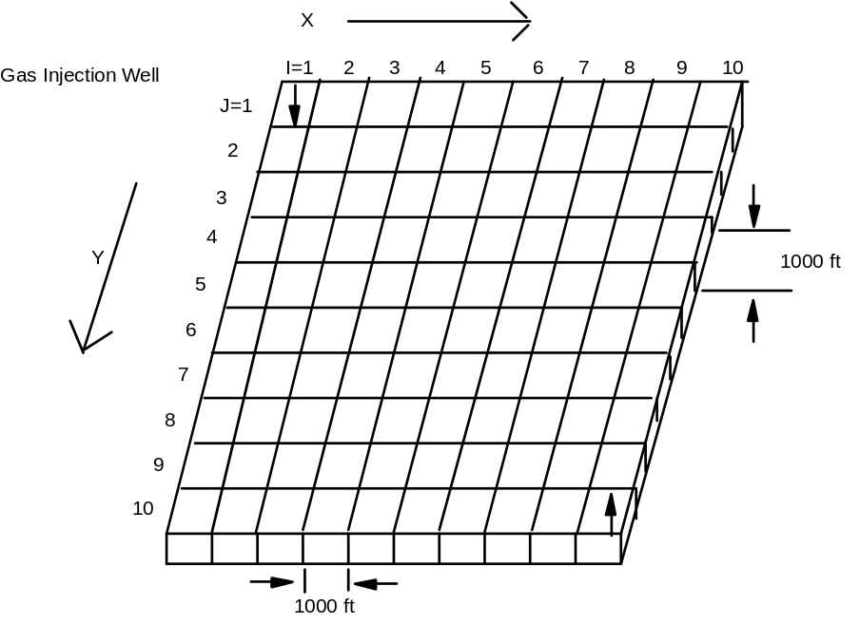
Oil Production Well
Areal Grid System

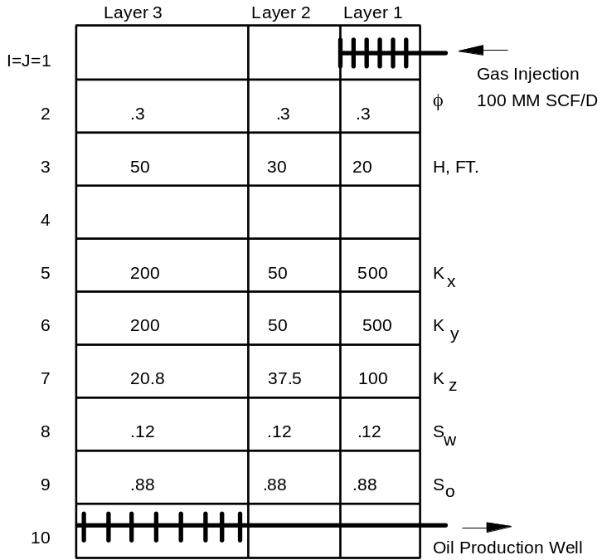
8425 ft 8325 ft.
8400 ft 8360 ft. 8335 ft.

Diagonal cross section
TABLE 5.5 - Basic Data and Problem Specifications for Example 5

RESERVOIR DATA

Initial reservoir pressure, psia at 8,400 ft 4,800
Rock compressibility, 1/psi 3 x 10⁻⁶
Porosity value of 0.3 was measured at a base pressure of 14.7 psi
Wellbore radius, ft 0.25
Skin 0
Reservoir Temperature, ºF 200
Gas specific gravity 0.792
Constant water viscosity, cp 0.3100
Density of saturated oil at stock tank conditions, lbm/cu. ft. 46.244
Density of saturated oil at stock tank conditions, lbm/cu. ft. 62.238
Density of gas at standard conditions (14.7 psia), lbm/cu. ft. 0.0647
Capillary pressure 0

PRODUCTION CONSTRAINTS

Gas injection rate, MMscf/D 100
Maximum oil production rate, STB/D 20,000
Minimum oil rate, STB/D 1,000
Minimum flowing bottomhole pressure, psi 1,000
Maximum saturation change during time step 0.05

PVT PROPERTIES

SATURATED OIL PVT FUNCTIONS GAS PVT FUNCTIONS SATURATED WATER
PVT FUNCTIONS
Reservoir Solution
Pressure FVF Viscosity GOR FVF Viscosity FVF
(psia) (RB/STB) (cp) (scf/stb) (RB/scf) (cp) (RB/bbl)

14.7 1.0620 1.0400 1.0 0.166666 0.008000 1.0410
264.7 1.1500 0.9750 90.5 0.012093 0.009600 1.0403
514.7 1.2070 0.9100 180.0 0.006274 0.011200 1.0395
1014.7 1.2950 0.8300 371.0 0.003197 0.014000 1.0380
2014.7 1.4350 0.6950 636.0 0.001614 0.018900 1.0350
2514.7 1.5000 0.6410 775.0 0.001294 0.020800 1.0335
3014.7 1.5650 0.5940 930.0 0.001080 0.022800 1.0320
3014.7 1.6950 0.5100 1270.0 0.000811 0.026800 1.0290
5014.7 1.8270 0.4490 1618.0 0.000649 0.030900 1.0258
9014.7 2.3570 0.2030 2984.0 0.000386 0.047000 1.0130

UNDERSATURATED OIL UNDERSATURATED WATER
PVT FUNCTIONS PVT FUNCTIONS

Reservoir
Pressure FVF VISCOSITY FVF
(psia) (RB/STB) (cp) (RB/bbl)
4014.7 1.6950 0.5100 1.0290
9014.7 1.5790 0.7400 1.0130

FIGURE 5.9
Oil Rate vs. Time for Example 5
Production Well in Cell (10, 10, 3)

OIL RATE, 10³ STB/D
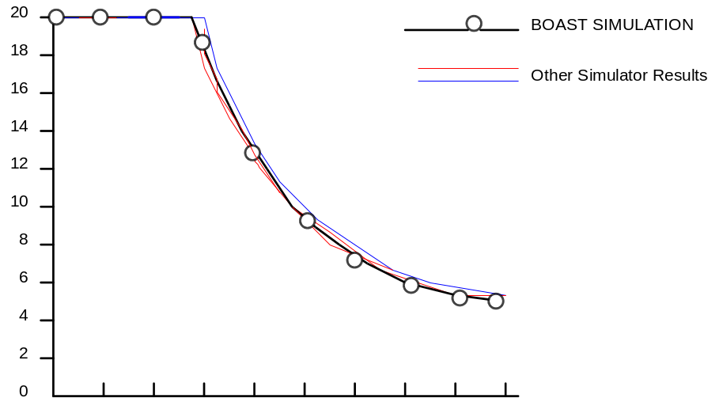
1 2 3 4 5 6 7 8 9 10
TIME, YEARS

FIGURE 5.10
Pressure vs. Time for Example 5
Production Well in Cell (10, 10, 3)

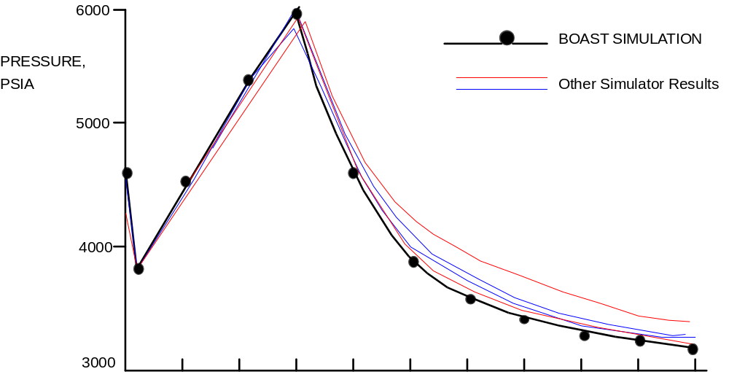
0 1 2 3 4 5 6 7 8 9 10
TIME, YEARS
FIGURE 5.11
Pressure vs. Time for Example 5
Injection Well in Cell (1, 1, 1)

PRESSURE, PSIA
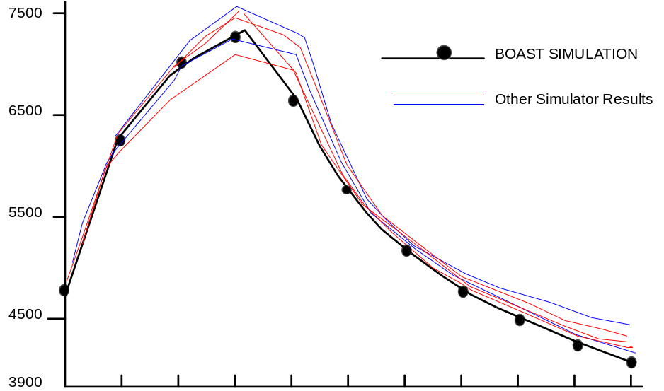
0 1 2 3 4 5 6 7 8 9 10
TIME, YEARS

FIGURE 5.12
Gas Saturation vs. Time for Example 5
Production Well in Cell (10, 10, 3)

GAS SATURATION, PERCENT
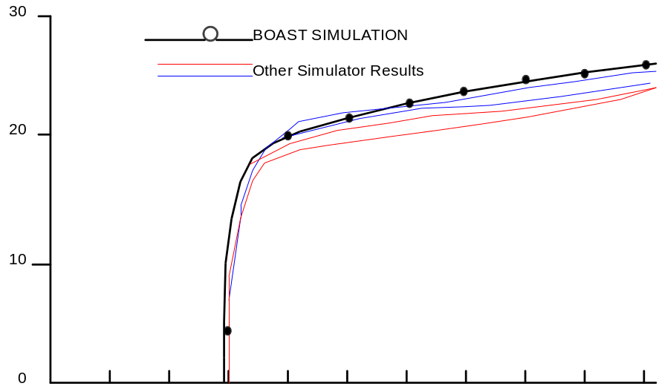
0 1 2 3 4 5 6 7 8 9 10
TIME, YEARS
FIGURE 5.13 -- GOR vs. Time for Example 5
Production Well in Cell (10, 10, 3)
GOR MSCF/STB
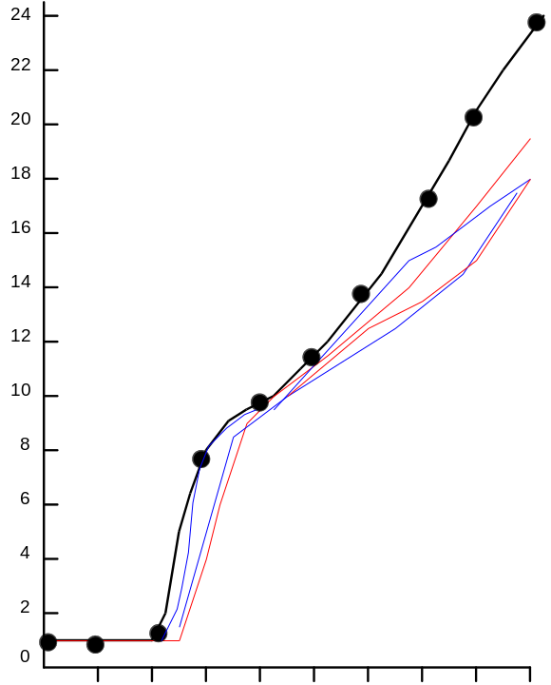
1 2 3 4 5 6 7 8 9 10
TIME, YEARS

FIGURE 5.14 - Pressure vs. Grid-Point Location for Example 5
Time = 8 Years; Top Layer
PRESSURE, PSIA
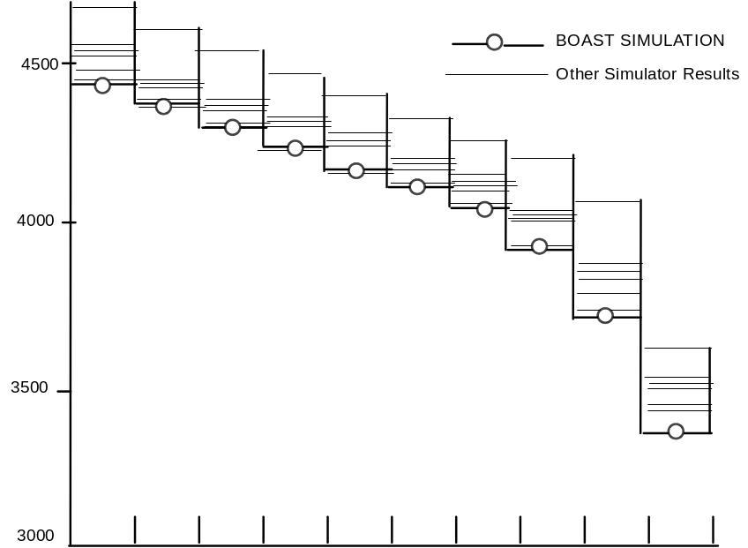
1,1 2,2 3,3 4,4 5,5 6,6 7,7 8,8 9,9 10,10
GRID POINT LOCATION

FIGURE 5.15--Gas Saturation vs. Grid-Point Location for Example 5
Time = 8 Years; Top Layer
GAS SATURATION, PERCENT
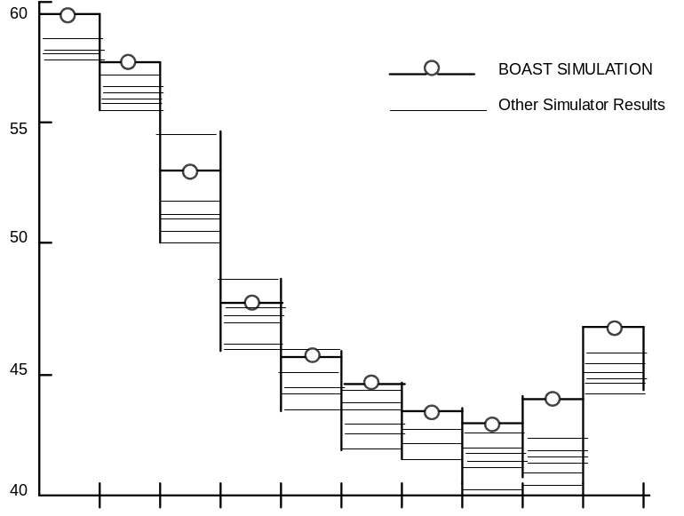
1,1 2,2 3,3 4,4 5,5 6,6 7,7 8,8 9,9 10,10
GRID POINT LOCATION

FIGURE 5.16 - Gas Saturation vs. Grid-Point Location for Example 5
Time = 8 Years; Middle Layer
GAS SATURATION, PERCENT
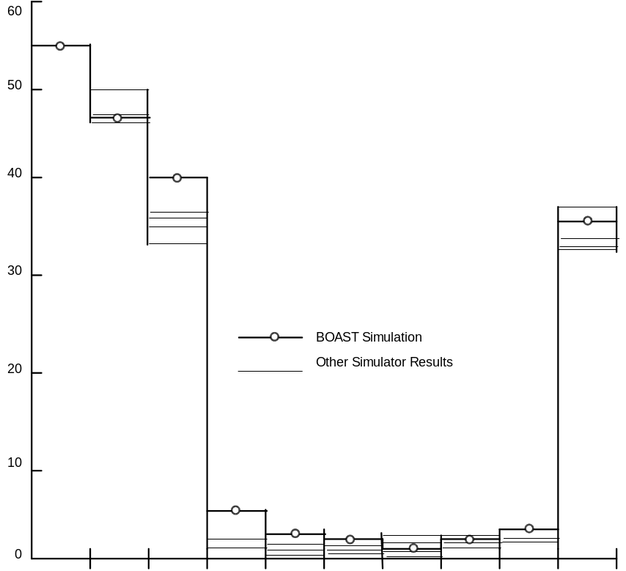
1,1 2,2 3,3 4,4 5,5 6,6 7,7 8,8 9,9 10,10
GRID POINT LOCATION
APPENDIX
Example of BOAST Program Output for the Two-Dimensional Areal Example Run
Presented in Chapter 5
(Example 2)

BOAST:
BLACK OIL APPLIED SIMULATION TOOL
(VERSION 1.1)

BOAST VALIDATION RUN -- PRESSURE COMPARISON EXAMPLE

GRID SIZE (DX) IN COLUMN 1 IS INITIALLY SET AT 160.00 FOR ALL NODES
GRID SIZE (DX) IN COLUMN 2 IS INITIALLY SET AT 160.00 FOR ALL NODES
GRID SIZE (DX) IN COLUMN 3 IS INITIALLY SET AT 160.00 FOR ALL NODES
GRID SIZE (DX) IN COLUMN 4 IS INITIALLY SET AT 160.00 FOR ALL NODES
GRID SIZE (DX) IN COLUMN 5 IS INITIALLY SET AT 80.00 FOR ALL NODES
GRID SIZE (DX) IN COLUMN 6 IS INITIALLY SET AT 160.00 FOR ALL NODES
GRID SIZE (DX) IN COLUMN 7 IS INITIALLY SET AT 160.00 FOR ALL NODES
GRID SIZE (DX) IN COLUMN 8 IS INITIALLY SET AT 160.00 FOR ALL NODES
GRID SIZE (DX) IN COLUMN 9 IS INITIALLY SET AT 160.00 FOR ALL NODES

GRID SIZE (DY) IN COLUMN 1 IS INITIALLY SET AT 160.00 FOR ALL NODES
GRID SIZE (DY) IN COLUMN 2 IS INITIALLY SET AT 160.00 FOR ALL NODES
GRID SIZE (DY) IN COLUMN 3 IS INITIALLY SET AT 160.00 FOR ALL NODES
GRID SIZE (DY) IN COLUMN 4 IS INITIALLY SET AT 160.00 FOR ALL NODES
GRID SIZE (DY) IN COLUMN 5 IS INITIALLY SET AT 80.00 FOR ALL NODES
GRID SIZE (DY) IN COLUMN 6 IS INITIALLY SET AT 160.00 FOR ALL NODES
GRID SIZE (DY) IN COLUMN 7 IS INITIALLY SET AT 160.00 FOR ALL NODES
GRID SIZE (DY) IN COLUMN 8 IS INITIALLY SET AT 160.00 FOR ALL NODES
GRID SIZE (DY) IN COLUMN 9 IS INITIALLY SET AT 160.00 FOR ALL NODES

GRID BLOCK DEPTH (DZ) IS INITIALLY SET AT 30.000 FOR ALL NODES

***********************NODE MIDPOINT ELEVATIONS *****************
K = 1

8360. 8360. 8360. 8360. 8360. 8360. 8360. 8360. 8360.
8360. 8360. 8360. 8360. 8360. 8360. 8360. 8360. 8360.
8360. 8360. 8360. 8360. 8360. 8360. 8360. 8360. 8360.

8360. 8360. 8360. 8360. 8360. 8360. 8360. 8360. 8360.
8360. 8360. 8360. 8360. 8360. 8360. 8360. 8360. 8360.

8360. 8360. 8360. 8360. 8360. 8360. 8360. 8360. 8360.
8360. 8360. 8360. 8360. 8360. 8360. 8360. 8360. 8360.

8360. 8360. 8360. 8360. 8360. 8360. 8360. 8360. 8360.

8360. 8360. 8360. 8360. 8360. 8360. 8360. 8360. 8360.

********POROSITY DISTRIBUTION FOLLOWS********

K = 1

.2800 .2800 .2800 .2800 .2800 .2800 .2800 .2800 .2800
.2800 .2800 .2800 .2800 .2800 .2800 .2800 .2800 .2800
.2800 .2800 .2800 .2800 .2800 .2800 .2800 .2800 .2800
.2800 .2800 .2800 .2800 .2800 .2800 .2800 .2800 .2800
.2800 .2800 .2800 .2800 .2800 .2800 .2800 .2800 .2800
.3000 .3000 .3000 .3000 .3000 .3000 .3000 .3000 .3000
.3000 .3000 .3000 .3000 .3000 .3000 .3000 .3000 .3000
.3000 .3000 .3000 .3000 .3000 .3000 .3000 .3000 .3000
.3000 .3000 .3000 .3000 .3000 .3000 .3000 .3000 .3000

PERMEABILITY (KX) IS INITIALLY SET AT 100.0000 FOR ALL NODES

PERMEABILITY (KY) IS INITIALLY SET AT 100.0000 FOR ALL NODES

PERMEABILITY (KZ) IS INITIALLY SET AT 100.0000 FOR ALL NODES

*****EMPIRICAL. DATA TABLE*****

SAT KRO KRW KRG PCOW PCGO

-0.1000 0.0000 0.0000 0.0000 0.00 0.00
0.0200 0.0000 0.0000 0.0000 0.00 0.00
0.1200 0.0000 0.0000 0.0200 0.00 0.00
0.2000 0.0000 0.0200 0.0600 0.00 0.00
0.3000 0.0000 0.0400 0.2000 0.00 0.00
0.4000 0.0300 0.0700 0.4600 0.00 0.00
0.5000 0.0900 0.1200 0.7000 0.00 0.00
0.6000 0.1700 0.1800 0.8700 0.00 0.00
0.7000 0.3000 0.2700 0.9100 0.00 0.00
0.8000 0.5000 0.5100 0.9400 0.00 0.00
0.8800 0.7500 0.7100 0.9700 0.00 0.00
1.0000 1.0000 1.0000 1.0000 0.00 0.00
1.1000 1.0000 1.0000 1.0000 0.00 0.00

PBO VSLOPE BSLOPE RSLOPE PMAX

4014.70 0.460E-04 -0.232F-04 0.00 9014.70

P MUO BO RSO

14.7 1.0400 1.0620 1.00
264.7 0.9750 1.1500 90.50
514.7 0.9100 1.2070 180.00
1014.7 0.8300 1.2950 371.00
2014.7 0.6950 1.4350 636.00
2514.7 0.6410 1.5000 775.00
3014.7 0.5940 1.5650 930.00
4014.7 0.5100 1.6950 1270.00
5014.7 0.4490 1.8270 1618.00
9014.7 0.2030 2.3570 2984.00

P MUW BW RSW

14.7 0.5000 1.0190 0.00
1011.7 0.5010 1.0160 0.00
2014.7 0.5020 1.0130 0.00
4014.7 0.5050 1.0070 0.00
6014.7 0.5100 1.0010 0.00
9014.7 0.5200 0.9920 0.00

P MUG BG CR

14.7 0.0080 .9358E+00 0.300E-05
264.7 0.0096 .6790E-01 0.300E-05
514.7 0.0112 .3523E-01 0.300E-05
1014.7 0.0140 .1795E-01 0.300E-05
2014.7 0.0189 .9063E-02 0.300E-05
2514.7 0.0208 .7266E-02 0.300E-05
3014.7 0.0228 .6064E-02 0.300E-05
4014.7 0.0268 .4554E-02 0.300E-05
5014.7 0.0309 .3644E-02 0.300E-05
9014.7 0.0470 .2167E-02 0.300E-05

RHOSCO RHOSCW RHOSCG
46.2440 62.2380 0.0647

*****SLOPES FOR COMPRESSIBILITY CALCULATIONS*****

P BO DBO/DP RSO DRSO/DP

264.7 1.1500 0.3520E-03 16.1 0.6376E-01
514.7 1.2070 0.2280E-03 32.1 0.6376E-01
1014.7 1.2950 0.1760E-03 66.1 0.6803E-01
2014.7 1.4350 0.1400E-03 113.0 0.4719E-01
2514.7 1.5000 0.1300E-03 138.0 0.4951E-01
3014.7 1.5650 0.1300E-03 165.6 0.5521E-01
4014.7 1.6950 0.1300E-03 226.2 0.6055E-01
5014.7 1.8270 0.1320E-03 288.1 0.6198E-01
9014.7 2.3570 0.1325E-03 531.4 0.6082E-01

P BW DBW/DP RSW DRSW/DP

1014.7 1.0160 -0.3000E-05 0.0 0.0000E+00
2014.7 1.0130 -0.3000E-05 0.0 0.0000E+00
4014.7 1.0070 -0.3000E-05 0.0 0.0000E+00
6014.7 1.0010 -0.3000E-05 0.0 0.0000E+00
9014.7 0.9920 -0.3000E-05 0.0 0.0000E+00

P BG DBGDP

264.7 0.6790E-01 -0.3472E-02
514.7 0.3523E-01 -0.1307E-03
1014.7 0.1795E-01 -0.3455E-04
2014.7 0.9063E-02 -0.8888E-05
2514.7 0.7266E-02 -0.3594E-05
3014.7 0.6064E-02 -0.2404E-05
4014.7 0.4554E-02 -0.1510E-05
5014.7 0.3644E-02 -0.9100E-06
9014.7 0.2167E-02 -0.3693E-06

*****GAS SATURATION*****

K = 1

0.000 0.000 0.000 0.000 0.000 0.000 0.000 0.000 0.000
0.000 0.000 0.000 0.000 0.000 0.000 0.000 0.000 0.000
0.000 0.000 0.000 0.000 0.000 0.000 0.000 0.000 0.000
0.000 0.000 0.000 0.000 0.000 0.000 0.000 0.000 0.000
0.000 0.000 0.000 0.000 0.000 0.000 0.000 0.000 0.000
0.000 0.000 0.000 0.000 0.000 0.000 0.000 0.000 0.000
0.000 0.000 0.000 0.000 0.000 0.000 0.000 0.000 0.000
0.000 0.000 0.000 0.000 0.000 0.000 0.000 0.000 0.000
0.000 0.000 0.000 0.000 0.000 0.000 0.000 0.000 0.000

****BUBBLE POINT PRESSURE DISTRIBUTION*****

K = 1

4015. 4015. 4015. 4015. 4015. 4015. 4015. 4015. 4015.
4015. 4015. 4015. 4015. 401.5. 4015. 4015. 4015. 4015.
4015. 4015. 4015. 4015. 4015. 4015. 4015. 4015. 4015.
4015. 4015. 4015. 4015. 401.5. 4015. 4015. 4015. 4015.
4015. 4015. 4015. 4015. 4015. 4015. 4015. 4015. 4015.
4015. 4015. 4015. 4015. 401.5. 4015. 4015. 4015. 4015.
4015. 4015. 4015. 4015. 4015. 4015. 4015. 4015. 4015.
4015. 4015. 4015. 4015. 401.5. 4015. 4015. 4015. 4015.
4015. 4015. 4015. 4015. 401.5. 4015. 4015. 4015. 4015.

*****WELL REPORT FOR ALL ACTIVE WELLS
ELAPSED TIME = 1.000000 DAYS FROM BEGINNING OF SIMULATION*****

-------------RATE------------ --------CUMULATIVE--------
WELL LOCATION CALC SPEC SPEC OIL GAS WATER OIL GAS WATER
ID I J K BHFP BHFP PI STB/D MCF/D STB/D GOR WOR MSTB MMCF MSTB
P-1 5 5 1 4113 0. 0.300 300. 381. 0. 1270. 0.000 0. 0. 0.
TOTALS 300. 381. 0. 0. 0. 0.

SUMMARY REPORT: BOAST (VERSION 1.1)

*****RESERVOIR PRESSURE DISTRIBUTION*****

k = 1

5377. 5376. 5375. 5375. 5774. 5375. 5375. 5376. 5377.
5376. 5375. 5374. 5373. F372. F373. 5374. 5375. 5376.
5375. 5374. 5372. 5369. 5367. 5369. 5372. 5374. 5375.
5375. 5373. 5369. 5362. 5354. 5362. 5369. 5373. 5375.
5375. 5373. 5367. 5354. 5309. 5354. 5367. 5373. 5375.
5375. 5373. 5369. 5362. 5354. 5362. 5369. 5373. 5375.
5376. 5374. 5372. 5369. 5368. 5369. 5372. 5374. 5376.
5376. 5376. 5374. 5373. 5373. 5373. 5374. 5376. 5376.
5377. 5376. 5376. 5375. 5375. 5375. 5376. 5376. 5377.

****OIL SATURATION****

K = 1

0.880 0.880 0.880 0.880 0.880 0.880 0.880 0.880 0.880
0.880 0.880 0.880 0.880 0.880 0.880 0.880 0.880 0.880
0.880 0.880 0.880 0.880 0.880 0.880 0.880 0.880 0.880
0.880 0.880 0.880 0.880 0.880 0.880 0.880 0.880 0.880
0.880 0.880 0.880 0.880 0.880 0.880 0.880 0.880 0.880
0.880 0.880 0.880 0.880 0.880 0.880 0.880 0.880 0.880
0.880 0.880 0.880 0.880 0.880 0.880 0.880 0.880 0.880
0.880 0.880 0.880 0.880 0.880 0.880 0.880 0.880 0.880
0.880 0.880 0.880 0.880 0.880 0.880 0.880 0.880 0.880

* Fanchi, J. R., K. J. Harpole, and S. W. Bujnowski: "BOAST: A Three-Dimensional, Three-Phase Black Oil Applied Simulation Tool, Volume I: Technical Description and FORTRAN Code"; U.S. DOE, BETC (1982).
* Odeh, A. S., "Comparison of Solutions to a Three-Dimensional Black-Oil Reservoir Simulation Problem", J. Pet. Tech., January 1981, pp. 13-25.

